Warepro Workshop

Introduction to WarePro: Basic Functionality Training

Key Component Of WarePro

System Administration:
- Table & Window
- Menu
- Callout
- Process
- Report
- DocAction
- Dashboard Widget
- Workflow

Creating a new window
A window provides create, read, update, and delete (CRUD) access to the data to a user.
These functionalities are provided by the standard tools and menus. A standard layout of a
window has the following parts:
- Search bar
- Tab bar
- Tool bar
- Tabs panel
- Status bar
- Menu
The following screenshot shows the different parts:

Search bar Tab bar Tool Bar
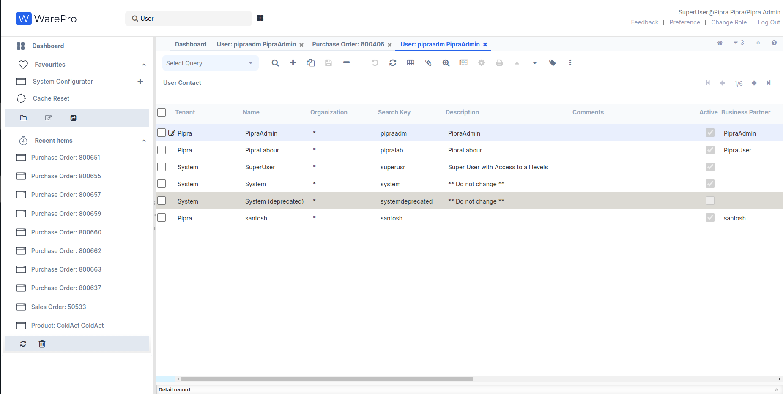
Status Bar Tabs Panel

Given the iDempiere architecture, as an author of a new window, you do not have to worry about how and what gets displayed in the Search Bar, Menu bar, Tool bar, and Status bar. All we need to focus on is the Tabs panel. And, in this recipe, we will go through the steps required to create a complete working new window in iDempiere, which will act as the foundation for building our MOM window.

1. Create the following table in your Adempiere schema:
Here's the corrected version of our instructions
- Check running Docker containers:
docker ps
- Login to the PostgreSQL container:
docker exec -it postgres bash
- Access the PostgreSQL database:
psql -U postgres
- Switch to the idempiere database:
\c idempiere
- Run our SQL query:

CREATE TABLE adempiere.c_mom (
c_mom_id numeric(10,0) NOT NULL PRIMARY KEY,
ad_client_id numeric(10,0) NOT NULL,
ad_org_id numeric(10,0) NOT NULL,
isactive character(1) DEFAULT 'Y'::bpchar NOT NULL,
created timestamp without time zone DEFAULT now() NOT NULL,
createdby numeric(10,0) NOT NULL,
updated timestamp without time zone DEFAULT now() NOT NULL,
updatedby numeric(10,0) NOT NULL,
value character varying(30) NOT NULL,
name character varying(255) NOT NULL,
start_date date NOT NULL,
start_time timestamp without time zone NOT NULL,
end_time timestamp without time zone NOT NULL,
chairperson character varying(80),
participants character varying(4000),
agenda character varying(4000),
discussion_detail character varying(8000));

iDempiere requires the following standard columns to be present on the tables, which
iDempiere populates on its own:

ad_client_id: Client Identifier
ad_org_id: Organization Identifier
isactive: Flag to indicate whether the record is active
created: Time when the record was created
createdby: ID of the user who created the record
updated: Time when the record was last updated
updatedby: ID of the user who last updated the record

Additionally, every table must have a primary key, which must follow the naming convention
of <table name>_id. c_mom_id which is the primary key of the c_mom table.

2. Run the desktop version of ADempiere and log in using System/System. Select the System Administrator as Role. After a successful login, You will see the Menu on the left-hand side of the window, and you will see the Application Dictionary related items:
Go to link and login
URL: https://localhost:8443/
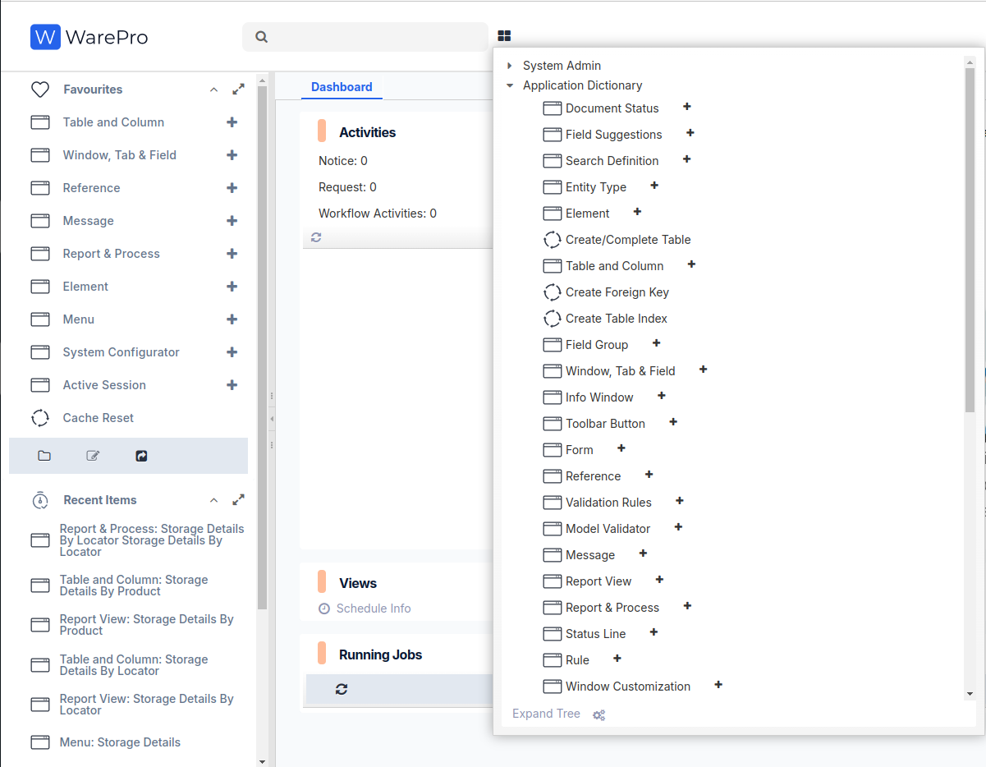

3. Click the Table and Column. It will pop up the Lookup Record: Table window where you click on the New Record + button on the bottom-left corner.

4. Enter the following details on to the Table tab as shown in the following screenshot:
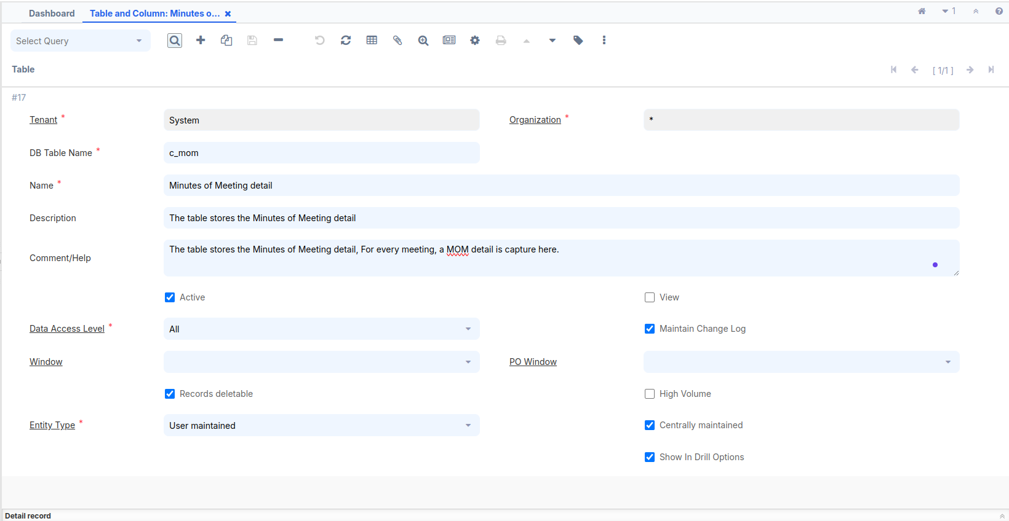
DB Table Name = c_mom
Name = Minutes of Meeting Detail
Description and Comment filed added your according or fill empty
Data Access Level = All
Entity Type = User maintained
Check the Show in Drill Options Check Box

5. In the previous image, we used the default Data Access Level—All. This is only to make sure that we are able to access the window using any role so that we don't have to log out as the System Administrator and log in with another role to be able to access the window. But, in a real world scenario, you may have to use other options such as Client level, Client and Organization level, System level, and so on.

6. Press the Setting button on the middle toolbar Or press Alt + O.
select Create Columns from DB button. This will bring up the Create Columns from DB window where it prompts you to select the Entity Type.

7. Select User maintained as the Entity Type, as shown in the following screenshot:

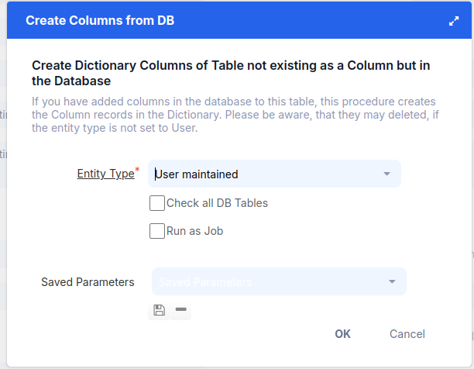

8. Click the OK button. It will pop-up a window showing all the columns generated from the table, as shown in the following screenshot:

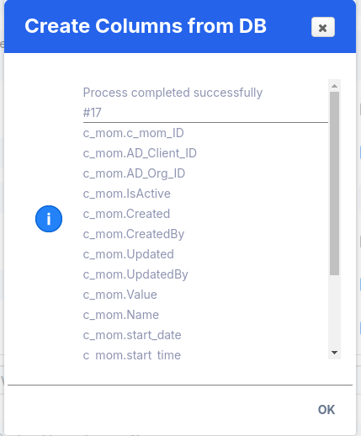
9. Click the ok button. This completes the creation of the columns, which you can verify by clicking on the Column tab.

Based on the data type of the columns in your database table, iDempiere guesses the data type of the columns, which you may want to use to store and retrieve data.For example, the Date on the column defaults to Date+Time in iDempiere, which may not be appropriate always as you may want to only store the date part of the timestamp. So, it is worth spending some time reviewing the Reference for the generated columns and making the required changes, if any.
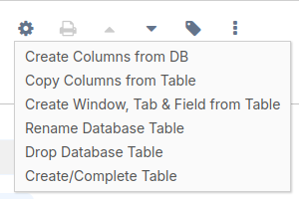
10. After making any column corrections, or directly, return to the main window.Press the Setting button on the middle toolbar Or press Alt + O.
Select Create Window,Tab & Field from Table, which is the third option on the list

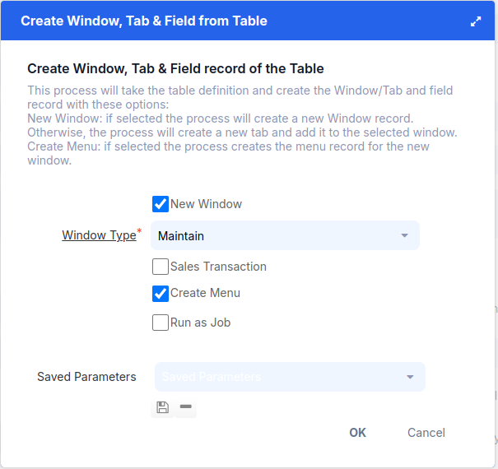
A new pop-up window will appear.
If we want to create a window, tab, and field, we can also create a menu.
Select the Create Menu checkbox and press OK.
Once the menu is created, it will be visible in the search bar.

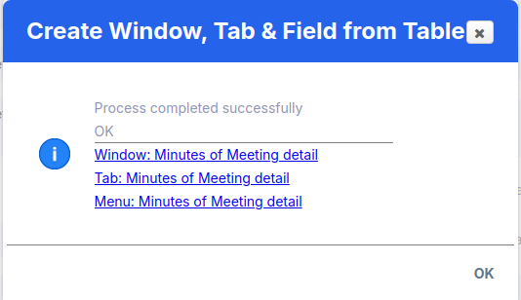

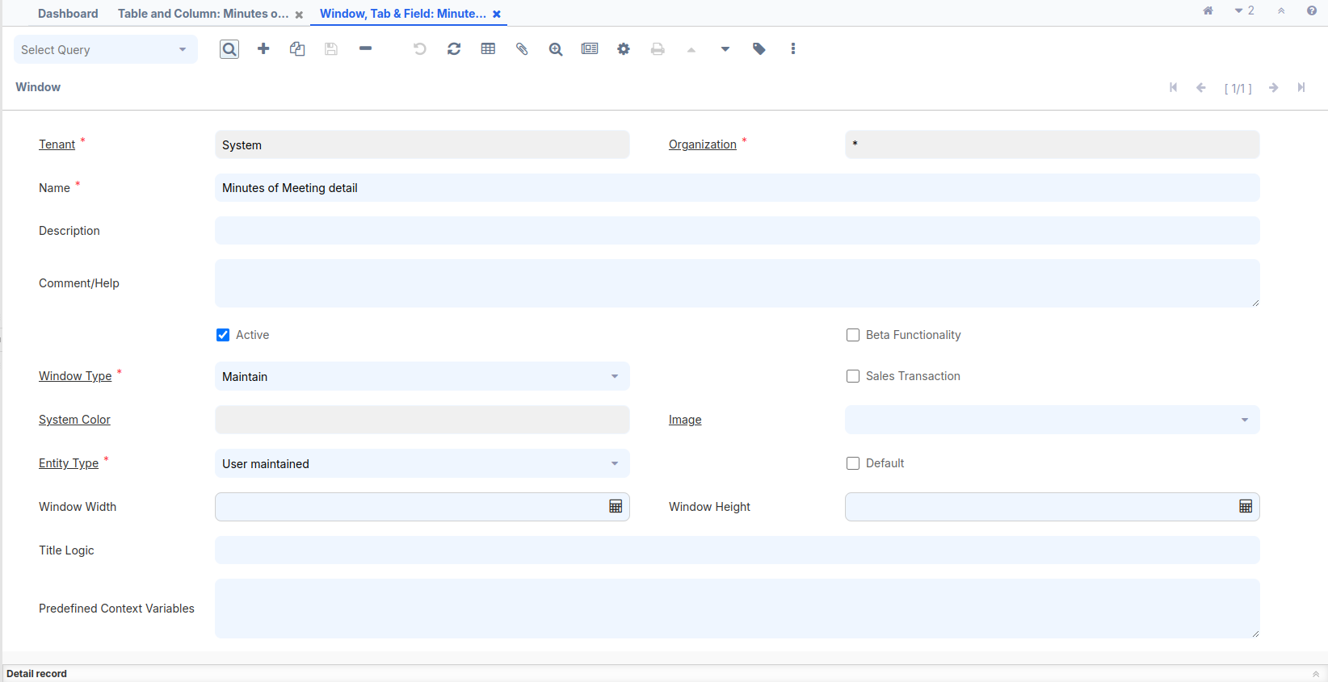
Open the Window, Tab,
and Field window,
and review the screenshot.
Make the necessary
changes according to
our requirements.
Window:-
- Name
- Window Type
- Sales Transaction

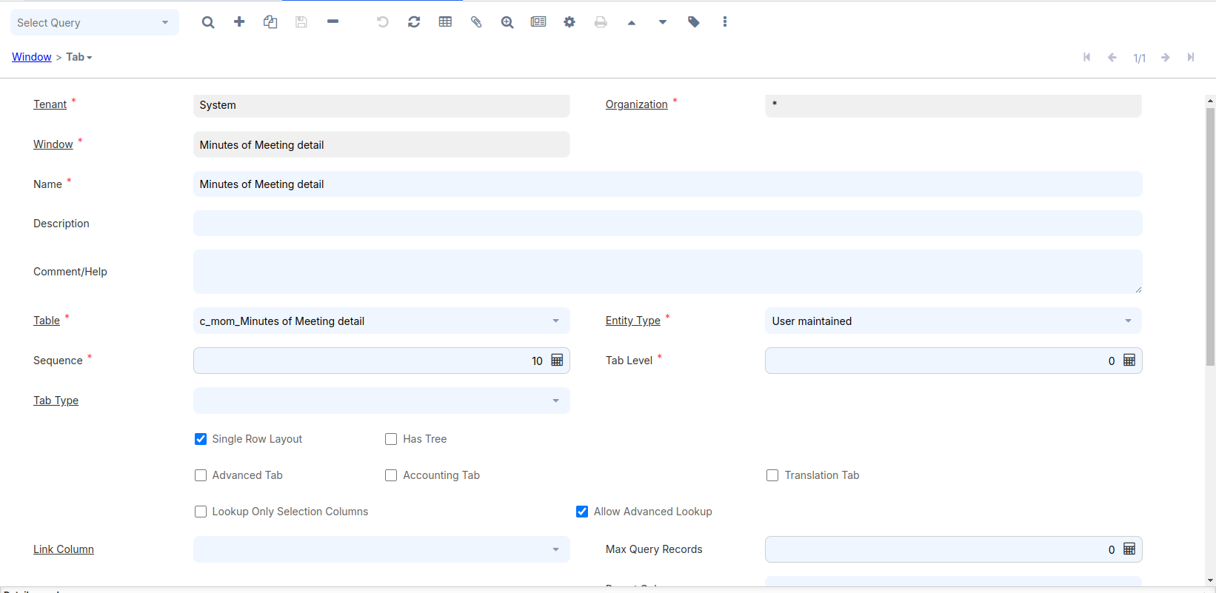
Tab:-
- Name
- Tab Level
- Single Row Layout
- Link Column
- Process
- Display Logic
- Read Only
- Sql Order By

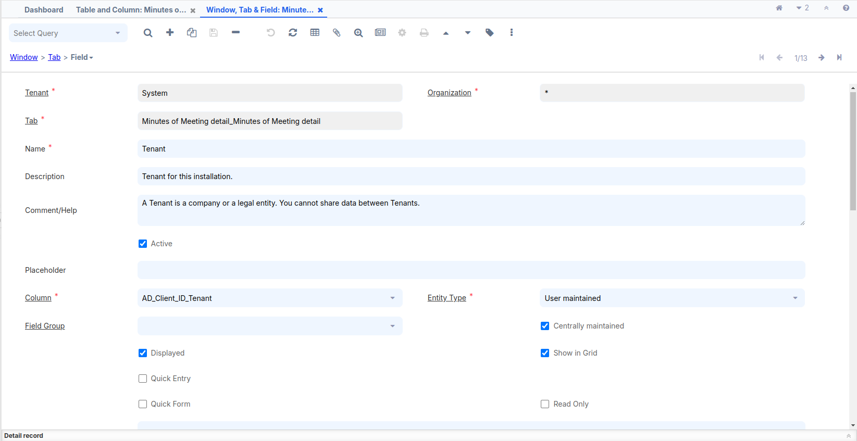
Field:-
- Name
- Description
- Field Group
- Displayed
- Read Only
- Show in Grid
- Field Only
- X Position
- Column Span
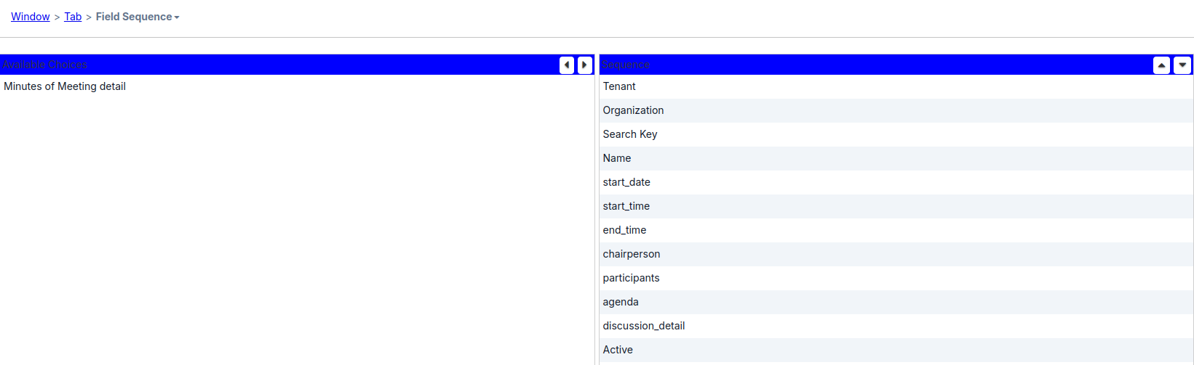

Go to the Field Sequence tab to see the default sequence in which the fields will appear on the tab. In case you want to change the sequence, you can do it in theSequence area. Select the field, whose sequence you want to change, and use the up and down arrow keys on the right to change the position of that field. Alternatively,you can also use the drag-n-drop for quicker re-ordering. The following screenshot
shows our fields after ordering:
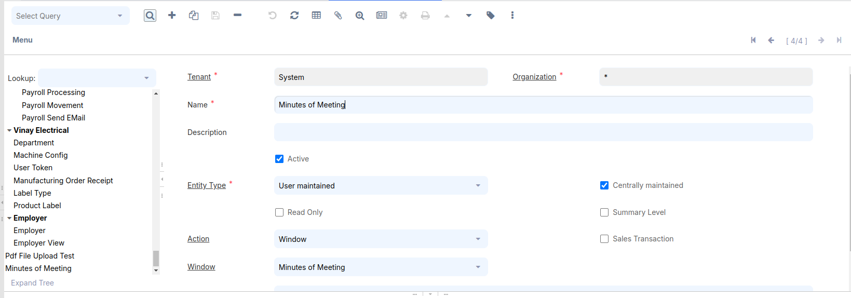

Enter Menu in
the search bar:
Menu:-
- Name
- Entity Type
- Action
- Window
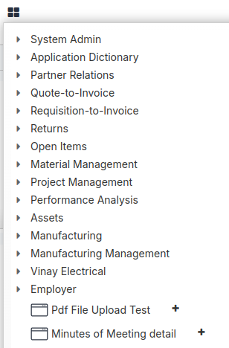
Menu Tree
Log out and log in as GardenAdmin/GardenAdmin. You will see the following Minutes Of Meeting menu item:

Click on the Minutes Of Meeting menu item. This will bring up the Minutes Of Meeting window with one tab, MOM. You will now be able to enter your MOM details and save it, as shown in the following screenshot:
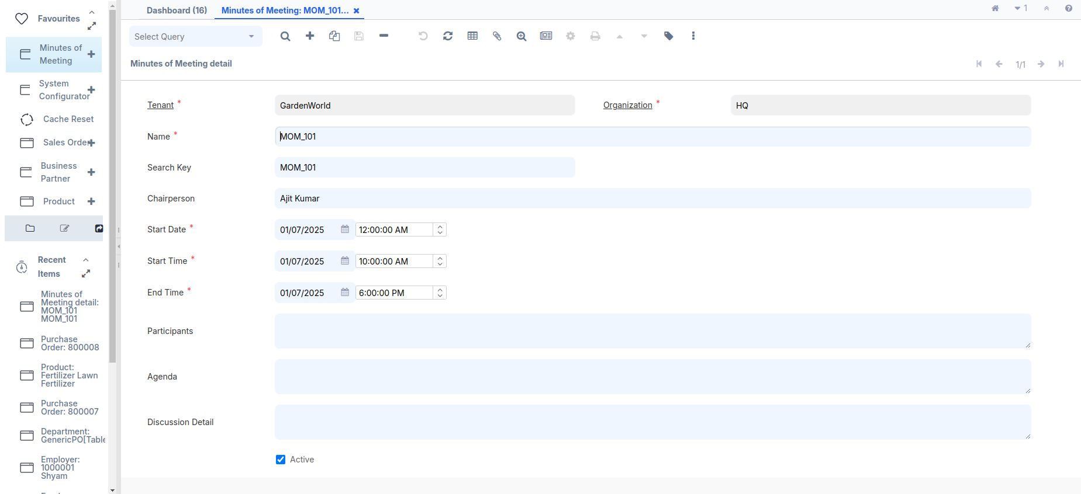
At this stage, we have got our basic MOM window ready where we are able to save/update the information. As a standard practice in ADempiere, the Search Key shall appear before the Name field. We will do this in the later part of this chapter. However, you may work with the field sequence to accomplish this.

Creating a window with multiple tabs

It is pretty common to logically relate the information using tabs. This recipe describes the steps to add multiple tabs in a window. So far, we have our basic MOM window. Now, we will break it into multiple tabs:
- The Participants detail is moved to a new tab—Participants
- The Discussion detail is refined and we are going to capture the following information as part of every discussion item:
# Item number
# Discussion description
# Actioned by
# Status
How to do it …
Log in to Adempiere using the credentials System/System
1.Delete some records from the c_mom table.
2. Enter the Search bar, go to the Window, Tab and Field sections, enter the window name Minutes of Meeting, navigate to the Field section, and delete the specified fields:
- Participants
- Discussion Detail
3. Enter the Search bar, go to the Table and Column sections,enter the Table and column name Minutes of Meeting,navigate to the column section, and delete the specified column:
- Participants
- discussion_detail
Please follow (Create the following table in your Adempiere schema) heading for create or alter table query,previously already guide
4. Alter the adempiere.c_mom table by running the following SQL:
ALTER TABLE adempiere.c_mom
DROP COLUMN participants,
DROP COLUMN discussion_detail;
5. Create two new tables by running the following SQL:
CREATE TABLE adempiere.c_mom_discussionline (
c_mom_discussionline_id numeric(10,0) NOT NULL PRIMARY KEY,
c_mom_id numeric(10,0) NOT NULL,
ad_client_id numeric(10,0) NOT NULL,
ad_org_id numeric(10,0) NOT NULL,
isactive character(1) DEFAULT 'Y'::bpchar NOT NULL,
created timestamp without time zone DEFAULT now() NOT NULL,
createdby numeric(10,0) NOT NULL,
updated timestamp without time zone DEFAULT now() NOT NULL,
updatedby numeric(10,0) NOT NULL,
item_nbr numeric (10,0) NOT NULL,
discussion_desc character varying(2000),
actionedby character varying(80) NOT NULL,
status character varying(80),
FOREIGN KEY (c_mom_id) REFERENCES adempiere.c_mom(c_mom_id));
CREATE TABLE adempiere.c_mom_participantsline (
c_mom_participantsline_id numeric(10,0) NOT NULL PRIMARY KEY,
c_mom_id numeric(10,0) NOT NULL,
ad_client_id numeric(10,0) NOT NULL,
ad_org_id numeric(10,0) NOT NULL,
isactive character(1) DEFAULT 'Y'::bpchar NOT NULL,
created timestamp without time zone DEFAULT now() NOT NULL,
createdby numeric(10,0) NOT NULL,
updated timestamp without time zone DEFAULT now() NOT NULL,
updatedby numeric(10,0) NOT NULL,
participant character varying(80),
company character varying(80) NOT NULL,
FOREIGN KEY (c_mom_id) REFERENCES adempiere.c_mom(c_mom_id));
c_mom: Represents the basic MOM detail
c_mom_discussionline: Represents each MOM discussion detail
c_mom_participantsline: Represents each MOM participant detail
6. Follow the steps mentioned in the Create a new window recipe to create the tables and their columns. The following screenshot shows the list of tables after the completion of the steps:
I have already mentioned how to create a table previously.
Create C_mom_discussionline table:
DB Table Name = C_mom_discussionline
Name = Discussion Detail
Description and Comment filed added your according or fill empty
Data Access Level = Client+Organization
Entity Type = User maintained
Check the Show in Drill Options Check Box
After saving the table press Alt + O and select Create Column from DB and all columns created.
Same create c_mom_participantsline table:
DB Table Name = c_mom_participantsline
Name = Participants
Description and Comment filed added your according or fill empty
Data Access Level = Client+Organization
Entity Type = User maintained
Check the Show in Drill Options Check Box
After saving the table press Alt + O and select Create Column from DB and all columns created.
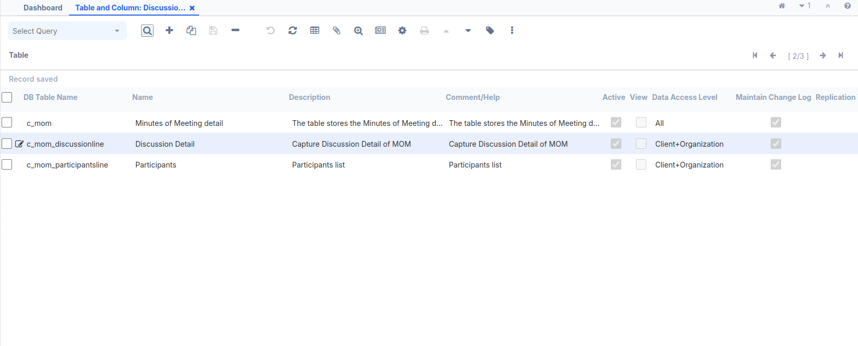
7. Create the Participants tab inside Minutes of Meeting window and switch to the single row view. The important fields are:
- Name = Participants
- Table: Select the participants table (c_mom_participantsline)
- Entity Type = User maintained
- Tab Level: 1
- UnCheck the Single Row Layout Check Box
- Link Column: Select the MOM (c_mom_ID_Minutes of Meeting details)
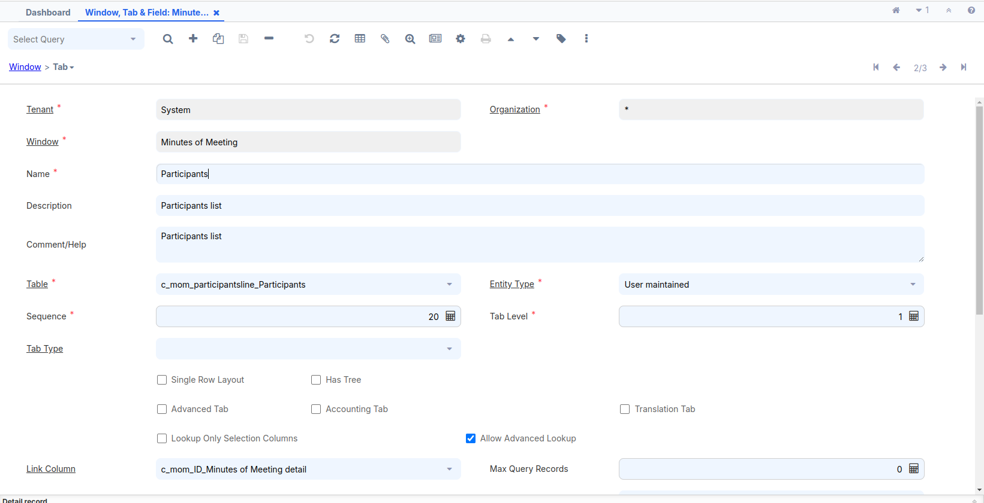
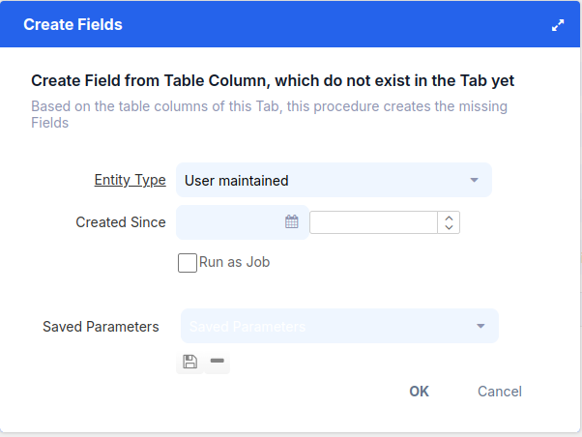
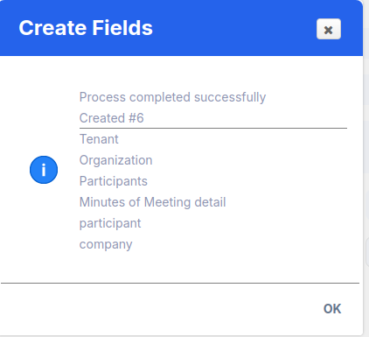
iDempiere uses Tab Level to indent the tab on a window and also, internally, uses it to create SQL joins to fetch the related records. The main tab has the tab level as 0, by default. Moreover, a tab with level 1' becomes the child of the main tab and is indented accordingly. For example, in the previous image, the tab Access has a tab level of the main tab—Window. Tabs with the same tab level are siblings or peers. For example, in the
In the previous image, the Access and Tab tabs are at the same tab level.
8. The above screen will appear after the tab record is created, and then we create a field.
Press the Settings Button on the middle toolbar or press Alt + O.
9. Review the Field Sequence tab and make the required changes to the sequence, as shown in the following screenshot:
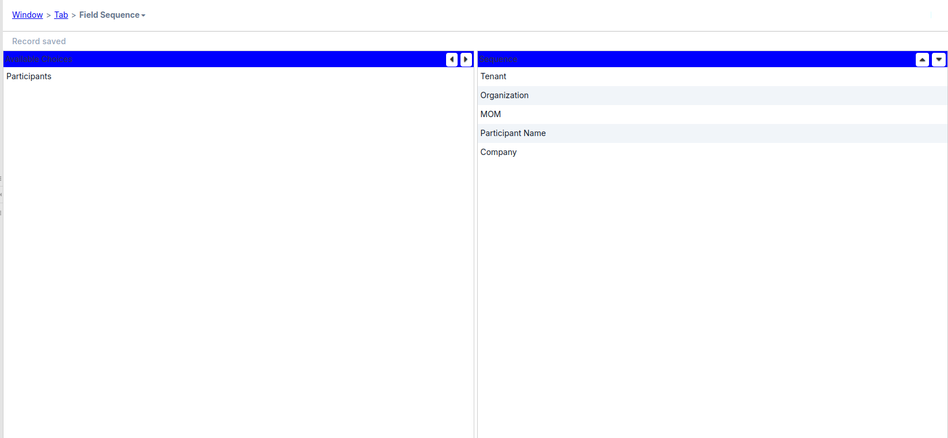
10. Create the Discussion Detail tab and switch to the single row view. The important fields are:
- Name = Discussion Detail
- Table: Select the participants table (c_mom_discussionline)
- Entity Type = User maintained
- UnCheck the Single Row Layout Check Box
- Tab Level: 1
- Link Column: Select the MOM (c_mom_ID_Minutes of Meeting details)
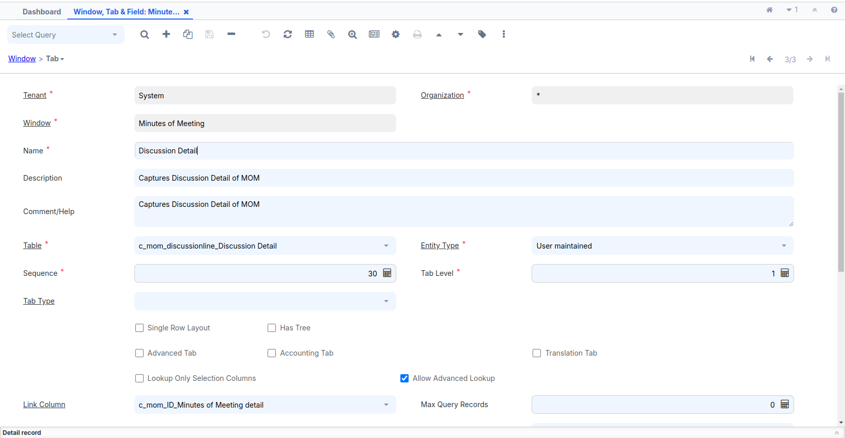
11. Review the Field Sequence tab and make the required changes to the sequence, as shown in the following screenshot:
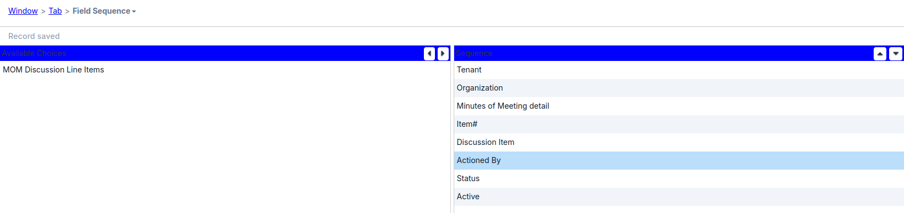
12. c_mom_participantsline and c_mom_discussionline tables, respectively, as shown in the following screenshot:
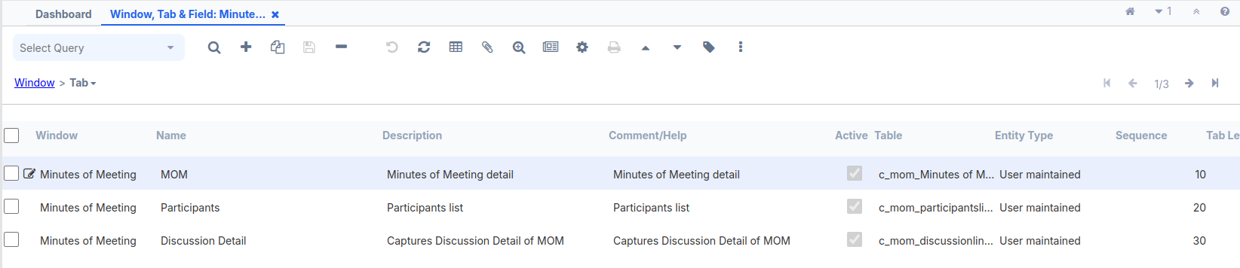
13. The Sequence field on the Tab screen determines the tab sequence. A tab with the least value of Sequence appears as the first tab and the one with the largest value appears as the last tab.
14. Log out and log in as GardenAdmin/GardenAdmin. You will see the Minutes Of Meeting menu tree,Or Use the search bar at the top left and enter Minutes Of Meeting :
15. Click on the Minutes Of Meeting menu tree. This will bring up the Minutes Of Meeting window with one tab, MOM. Our MOM window now has three tabs and looks more organized, as shown here in the following screenshot:
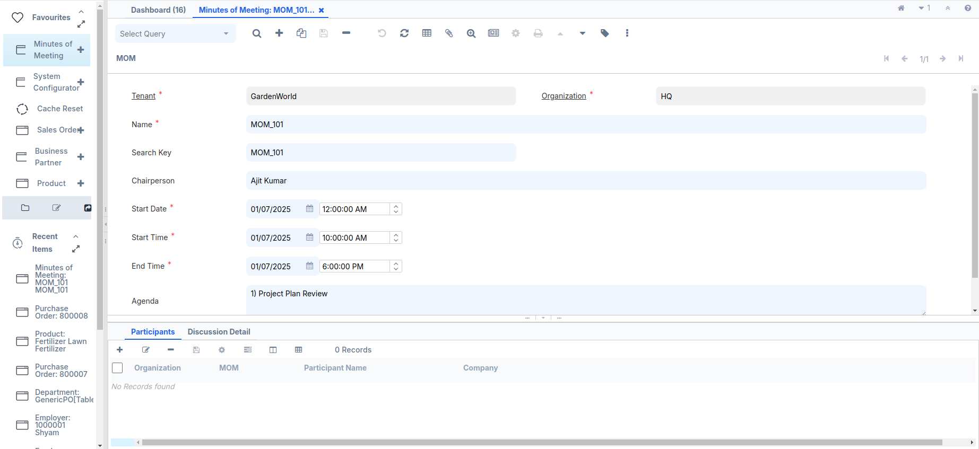
16. Add one or more participants for a MOM:
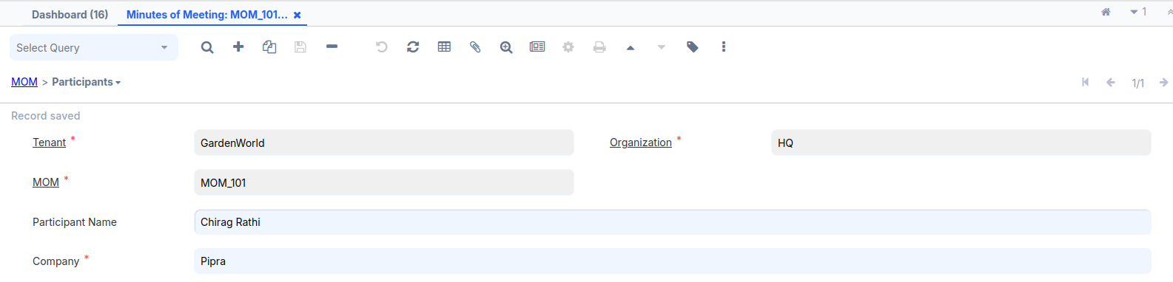
17. Add one or more discussion items for a MOM:
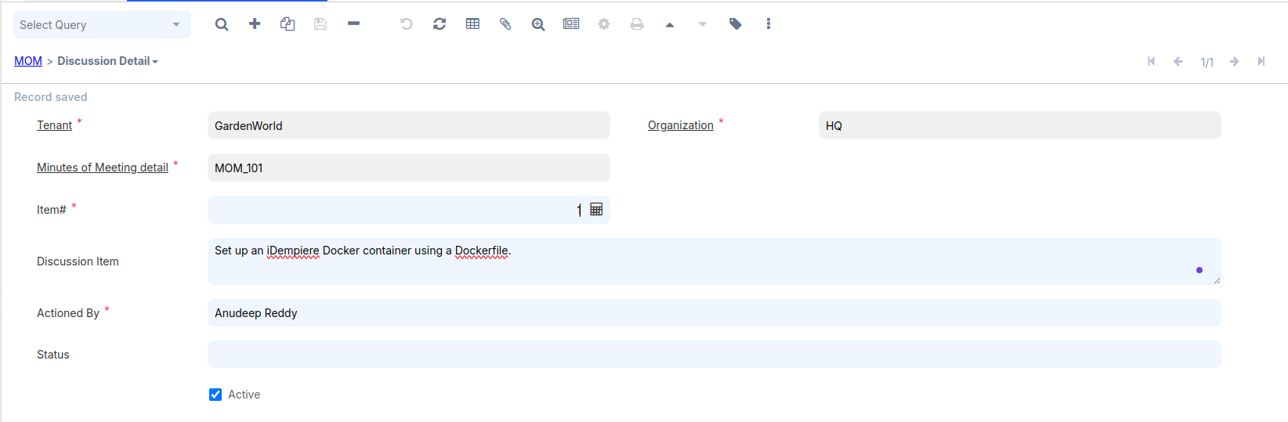

Creating a Search Widget

On the MOM tab, we have the Chairperson field where we are entering the
username.Similarly, we have the participant's name on the Participants tab and the Actioned By person name on the Discussion Detail tab. iDempiere maintains User/Contact detail. To provide a better finishing of our MOM window, it would be good if we can connect these fields with ADempiere's User/Contact so that a user can find the right User/Contact and assign them to a MOM. This way, all these fields need to be made like a search widget where a Search button appears next to these fields. When a user clicks on the Search button, he/she will be able to find the User/Contact, and upon selection, the selected User/Contact will appear in the field. As part of this recipe, we will follow through the steps required to convert each of these fields into a search widget.
Log in to Adempiere using the credentials System/System
1. Delete some records from the c_mom_participantsline table.
2. Enter the Search bar, go to the Window, Tab and Field sections, enter the window name Minutes of Meeting,Go to Participants tab, navigate to the Field section, and delete the specified fields:
Participants
3. Enter the Search bar, go to the Table and Column sections,enter the Table and column name Participants,navigate to the column section, and delete the specified column:
Participant
Please follow (Create the following table in your Adempiere schema) heading for create or alter table query,previously already guided.

Alter the adempiere.c_mom_participantsline table by executing the following SQL:
ALTER TABLE adempiere.c_mom_participantsline DROP COLUMN participant;
ALTER TABLE adempiere.c_mom_participantsline ADD COLUMN ad_user_id NUMERIC(10,0) ;
ALTER TABLE adempiere.c_mom_participantsline ADD CONSTRAINT c_mom_participantsline_ad_user_id_fkey FOREIGN KEY (ad_user_id)REFERENCES adempiere.ad_user(ad_user_id);
1. Delete some records from the c_mom table.
2. Enter the Search bar, go to the Window, Tab and Field sections, enter the window name Minutes of Meeting,Go to Minutes of Meeting tab, navigate to the Field section, and delete the specified fields:
Chairperson
3. Enter the Search bar, go to the Table and Column sections,enter the Table and column name Minutes of Meeting,navigate to the column section, and delete the specified column:
chairperson
Alter the adempiere.c_mom table by executing the following SQL:
ALTER TABLE adempiere.c_mom DROP COLUMN chairperson;
ALTER TABLE adempiere.c_mom ADD COLUMN ad_user_id NUMERIC(10,0) ;
ALTER TABLE adempiere.c_mom ADD CONSTRAINT c_mom_ad_user_id_fkey FOREIGN KEY (ad_user_id)REFERENCES adempiere.ad_user(ad_user_id);

Log in to Adempiere using the credentials System/System. Follow steps:
- Search for the table and column.
- Enter the Minutes of Meeting table name.
- Press Alt + O and select Create Columns from DB to update with new columns.
- Navigate to the new column and update some fields as needed.
Select the AD_User_ID column and specify the following values for the two important fields, which are more relevant in this context :
- Reference: Select Search
- Reference Key: Select AD_User
After completed above same step do Participants table name
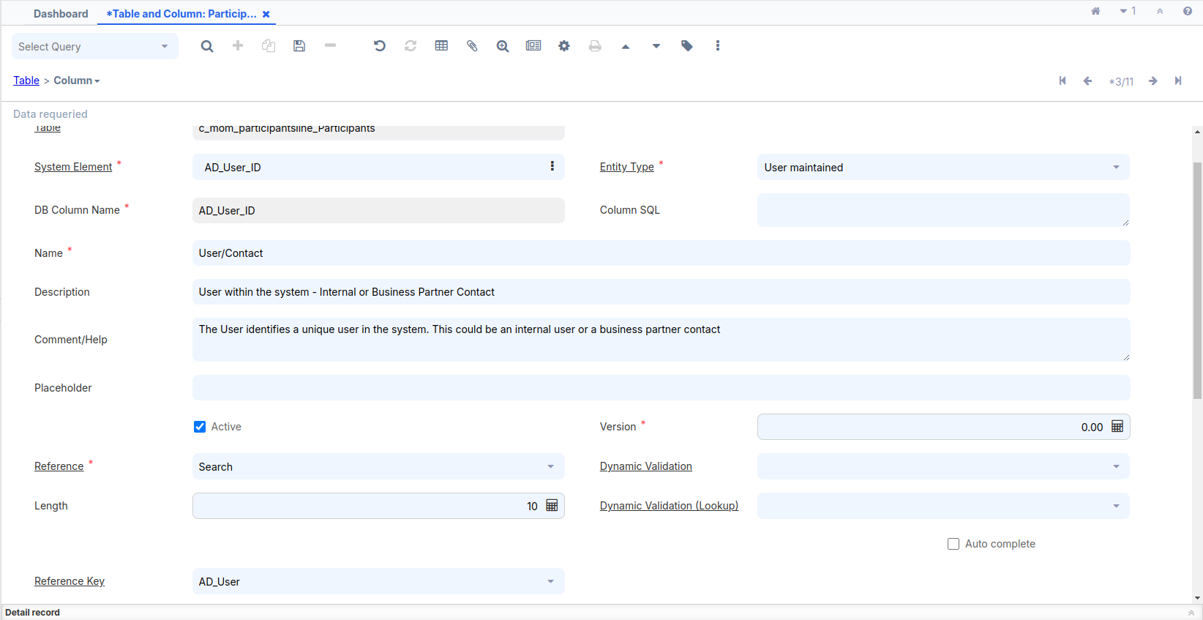
Go to the Window, Tab, and Field window and look at the details of the Minutes Of Meeting window.
Click on the Create Fields button so that the newly added User/Contact column is added as a field. Change the sequence of the User/Contact field such that it comes before Company.
Rename the field name as follows:
1. In the Minutes of Meeting tab, change the field name User/Contact to
Chairperson.
2. In the Participants tab, change the field name User/Contact to
Participant.
Log out and log in as GardenAdmin/GardenAdmin with the GardenWorld Admin role.
Go to the Minutes Of Meeting window and go to the Participants tab. You will notice that the User/Contact field is populated, by default, with the current logged in username and a search button appears next to the field, as shown in the following screenshot:
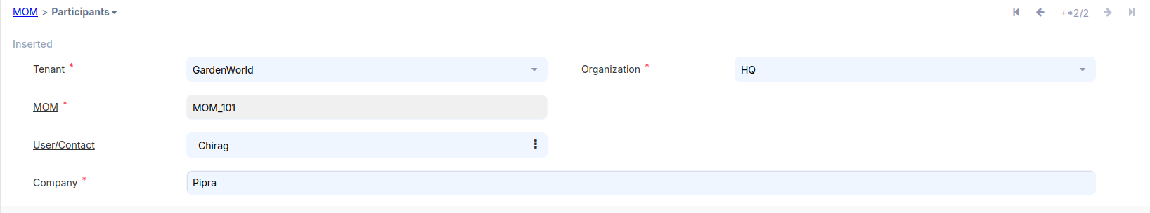

Populating the Combo-box list
There is a Status field on the Discussion Detail tab. Currently, this field accepts free text.For various practical reasons, such as, to maintain the consistency in communication, to support project guidelines, to have clean data for further analysis and reporting, and so on, it makes sense to convert the Status field into a combo-box and the possible values are listed for the user selection. In this recipe, we will follow the steps to convert the Status field into a combo-box and configure it in such a way that it is populated with values.
Log in to the System/System account, and remove the status field in the Window, Tab, and Field window. After that, remove the status column in the Table and Column window. Once both steps are completed, drop the column from the PostgreSQL table.
1. Delete some records from the c_mom_discussionline table.
2. Enter the Search bar, go to the Window, Tab and Field sections, enter the window name Minutes of Meeting,Go to Discussion Detail tab, navigate to the Field section, and delete the specified fields:
Status
3. Enter the Search bar, go to the Table and Column sections,enter the Table and column name Discussion Detail,navigate to the column section, and delete the specified column:
status
Drop the status column by executing the following SQL:
ALTER TABLE adempiere.c_mom_discussionline DROP COLUMN status;
Create a new table, c_momstatus, to capture the list of status values by executing the following SQL:
CREATE TABLE adempiere.c_mom_status (
c_mom_status_id NUMERIC(10,0) NOT NULL PRIMARY KEY,
c_mom_status_uu VARCHAR(36) DEFAULT NULL::bpchar,
ad_client_id NUMERIC(10, 0) NOT NULL,
ad_org_id NUMERIC(10, 0) NOT NULL,
name varchar(25) NOT NULL,
value character varying(40) NOT NULL,
created TIMESTAMP without time zone DEFAULT now() not null,
createdby numeric(10,0) not null,
updated TIMESTAMP without time zone DEFAULT now() not null,
updatedby NUMERIC(10,0) not null,
description VARCHAR(255),
isactive CHAR(1) not null DEFAULT 'Y'::bpchar,
isdefault character(1) NOT NULL DEFAULT 'N');

Log in to the System/System account and create a table and columns for the new table. Similarly, create the corresponding window, tab, field, and menu. These steps have already been performed previously for the c_mom table.
Create C_mom_status table:
DB Table Name = c_mom_status
Name = MOM Status
Description and Comment filed added your according or fill empty
Data Access Level = Client+Organization
Entity Type = User maintained
Check the Show in Drill Options Check Box
After saving the table press Alt + O and select Create Column from DB and all columns created.
After done press Alt + O and Select Create Window,Tab & Field from Table, which is the third option on the list
A new pop-up window will appear.
If we want to create a window, tab, and field, we can also create a menu.
Select the Create Menu checkbox and press OK.
Once the menu is created, it will be visible in the search bar.
Log out and log in as GardenAdmin/GardenAdmin with the GardenWorld Admin role.
Go to the MOM Status window and create different statuses. For example, Let us say that Open is marked as the default status, as shown in the following screenshot:
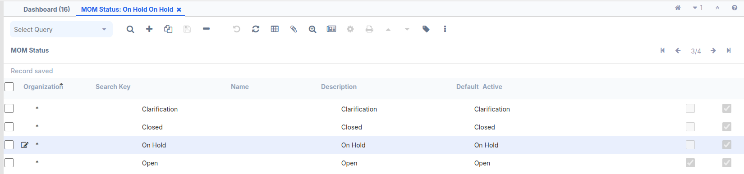
The c_mom_status_ID column is linked to the c_mom_discussionline table. A foreign key should be used to establish the relationship between the two tables.
Alter the adempiere.c_mom_discussionline table by executing the following SQL:
ALTER TABLE adempiere.c_mom_discussionline ADD COLUMN c_mom_status_id NUMERIC(10,0) ;
ALTER TABLE adempiere.c_mom_discussionline ADD CONSTRAINT c_mom_discussionline_c_mom_status_id_fkey FOREIGN KEY (c_mom_status_id) REFERENCES adempiere.c_mom_status(c_mom_status_id);
Log in to Adempiere using the credentials System/System. Follow steps:
- Search for the table and column.
- Enter the Discussion Detail table name.
- Press Alt + O and select Create Columns from DB to update with new columns.
- Navigate to the new column and update some fields as needed.
- Go to the Window, Tab, and Field window and look at the details of the Minutes Of Meeting window.
- Click on the Create Fields button so that the newly added MOM Status column is added as a field.

Log out and log in as GardenAdmin/GardenAdmin with the GardenWorld Admin role.
Go to the Minutes Of Meeting window and go to the Discussion Detail tab. You will notice that the MOM Status field is populated, by default, with the current logged in username and a Combo-Box list appears next to the field, as shown in the following screenshot:
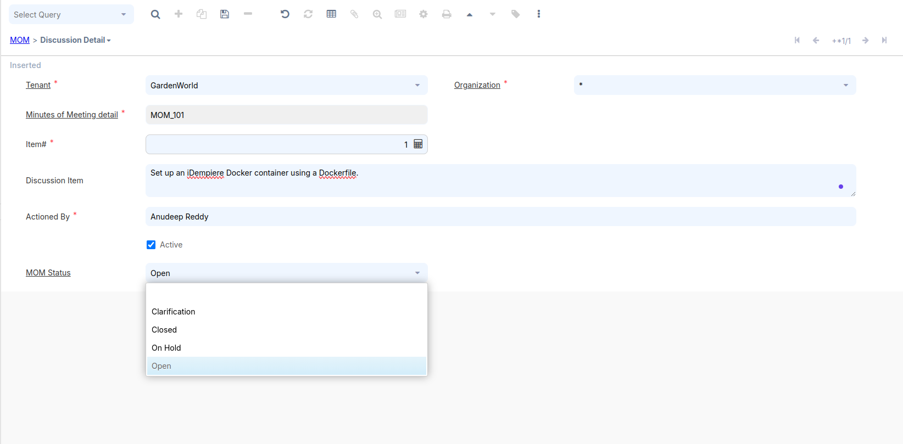

CallOut

Callout is mainly used to perform some dynamic actions when a value in a particular field is changed. Each field in ADempiere maps to a column in a particular table, so callout is configured at column level. Callout is a Java method that gets invoked when there is a change in the field data in a tab.

How to do it…

- For Eclipse
We have a Maven plug-in (org.mom.calloutandprocessanddocaction) that needs to be imported into Eclipse.
Include the required code to import the plugin. Then, in the
Run Configurations, located in the Run dropdown in the top-middle
toolbar, select the plugin and ensure the following settings:
- Set the Start Level to 1.
- Enable Auto-Start by setting it to true.
After making these changes, apply them and run the application.
OR
First, download the org.mom.calloutandprocessanddocaction JAR file. Then, use this JAR file within the OSGi framework.
Added Plug-in using OSGI frame work:-
A. Open your browser and go to: https://localhost:8443/
B. A new pop-up window will appear. On the top right, you will
see three tools. Click on the Settings tool.
C. use credential SuperUser/System
D. Click Install/Update at the top right.
E. A new pop-up window will open—check the first two checkboxes,
select your JAR file, and press the Install/Update button.
F. After the installation is complete, search for the plugin (mom).
G. Start the plugin, refresh the page, and the OSGi framework
setup will be completed.

Java Code:-
package org.mom.callout;

import java.sql.PreparedStatement;
import java.sql.ResultSet;
import java.sql.SQLException;
import java.util.Properties;
import java.util.logging.Level;
import org.compiere.model.CalloutEngine;
import org.compiere.model.GridField;
import org.compiere.model.GridTab;
import org.compiere.util.CLogger;
import org.compiere.util.DB;
import org.compiere.util.Env;

public class MyCallout extends CalloutEngine{

CLogger log = CLogger.getCLogger(MyCallout.class);

public String getNextItemNbr (Properties ctx, int WindowNo,
GridTab mTab, GridField mField, Object value)
{
Integer momId = (Integer)mTab.getValue("c_mom_ID");
String sql = "SELECT MAX(item_nbr) "
+ "FROM c_mom_discussionline "
+ "WHERE c_mom_ID=?";
PreparedStatement pstmt = null;
ResultSet rs = null;
try {

pstmt = DB.prepareStatement(sql, null);
pstmt.setInt(1, momId);
rs = pstmt.executeQuery();
Integer maxItemNbr = 0;
if (rs.next())
{
maxItemNbr = rs.getInt(1);
Env.setContext(ctx, WindowNo, "item_nbr", maxItemNbr+1);
mTab.setValue("item_nbr", maxItemNbr+1);
}
DB.close(rs, pstmt);
rs = null;
pstmt = null;

}catch(SQLException e) {
log.log(Level.SEVERE,sql,e);
return e.getLocalizedMessage();
}finally {
DB.close(rs,pstmt);
rs = null;
pstmt = null;
}

return "";

}
}
- Launch the desktop version of the project and log in as System/System with the System Administrator role.
- Go to the Table and Column window and open the details of the c_mom_ID column in the c_mom_discussionline table and mention org.mom.callout.MyCallout.getNextItemNbr as the Callout, as shown in the following screenshot:
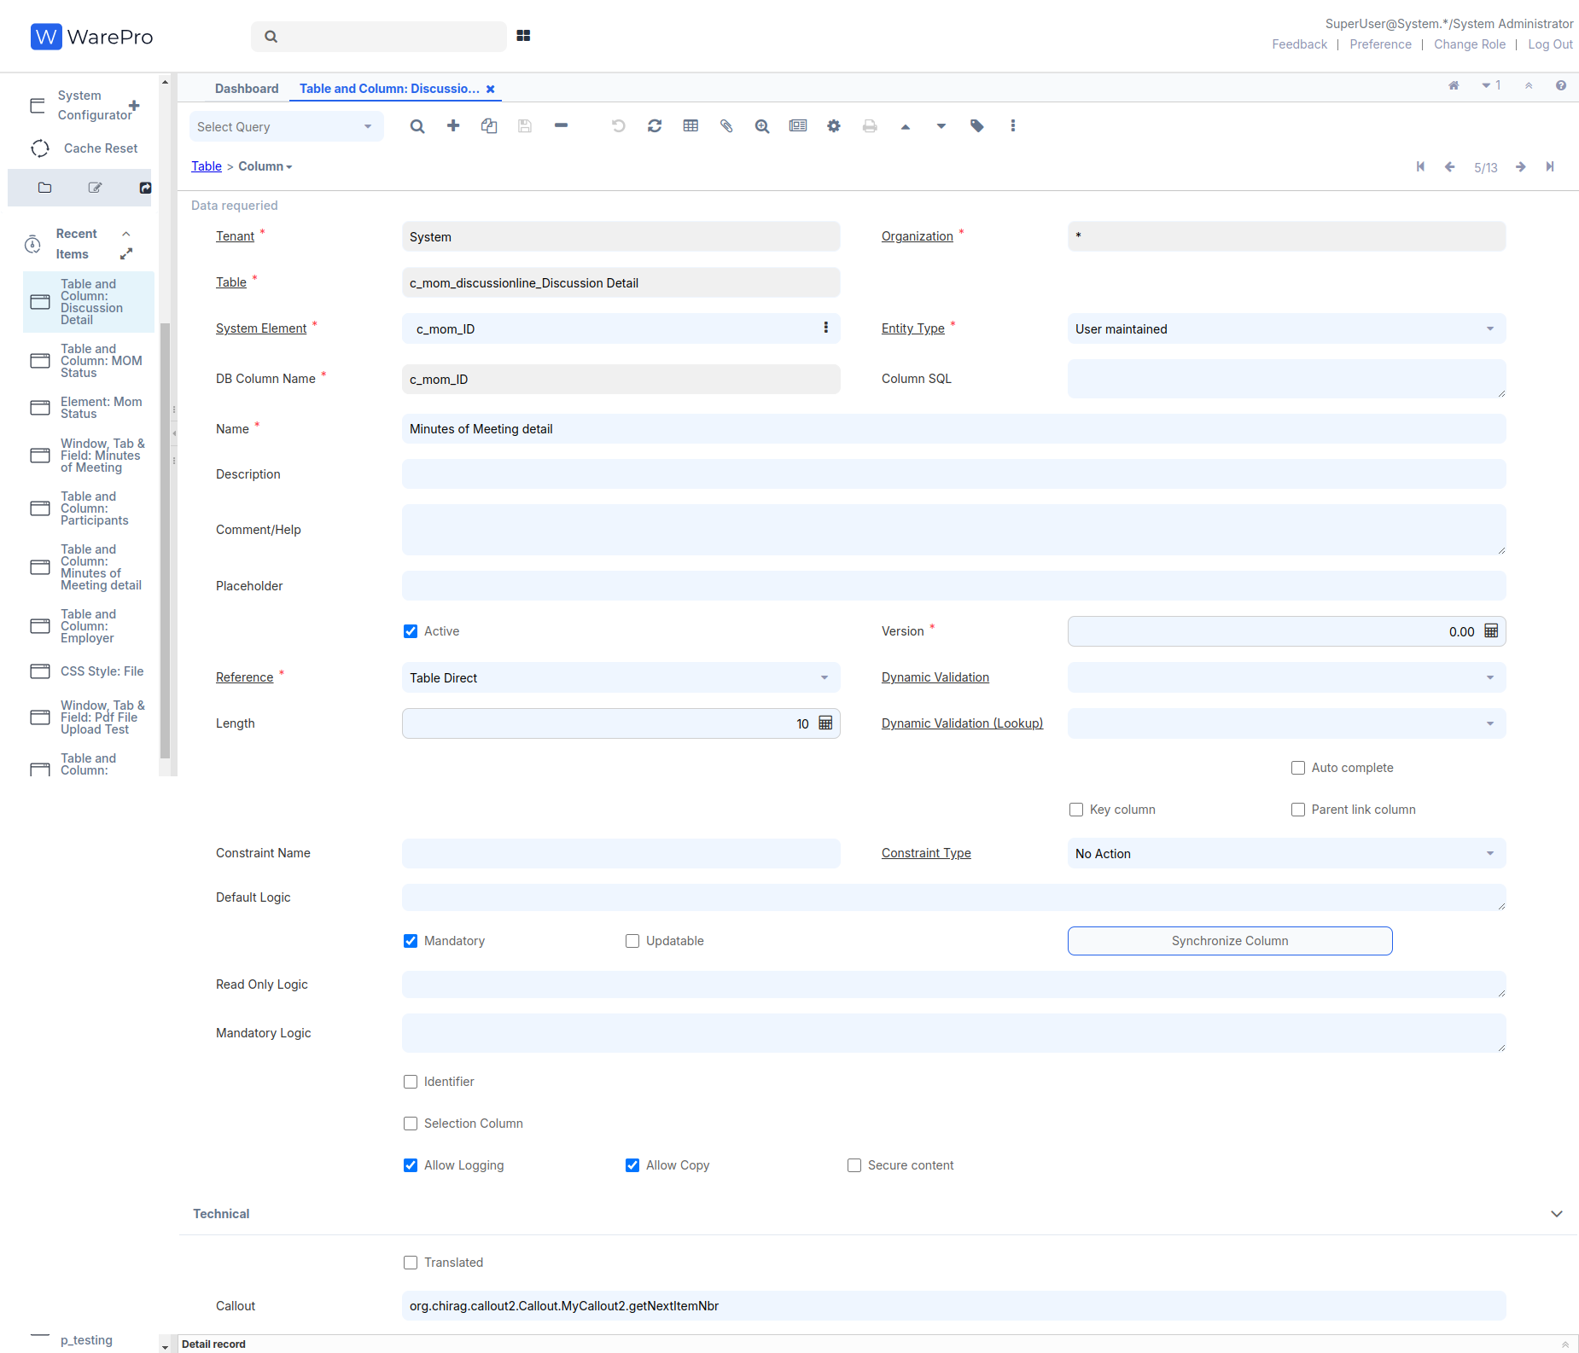
After saving the record, go to the search bar, enter Cache Reset, and click OK.
- Log out and log in as GardenAdmin/GardenAdmin with the GardenWorld Admin role.
- Go to the Discussion Detail tab of the Minutes Of Meeting window and click on the New Record (+ Icon) toolbar button. The item number is automatically generated and the sequence is maintained, as shown in the next screenshot:
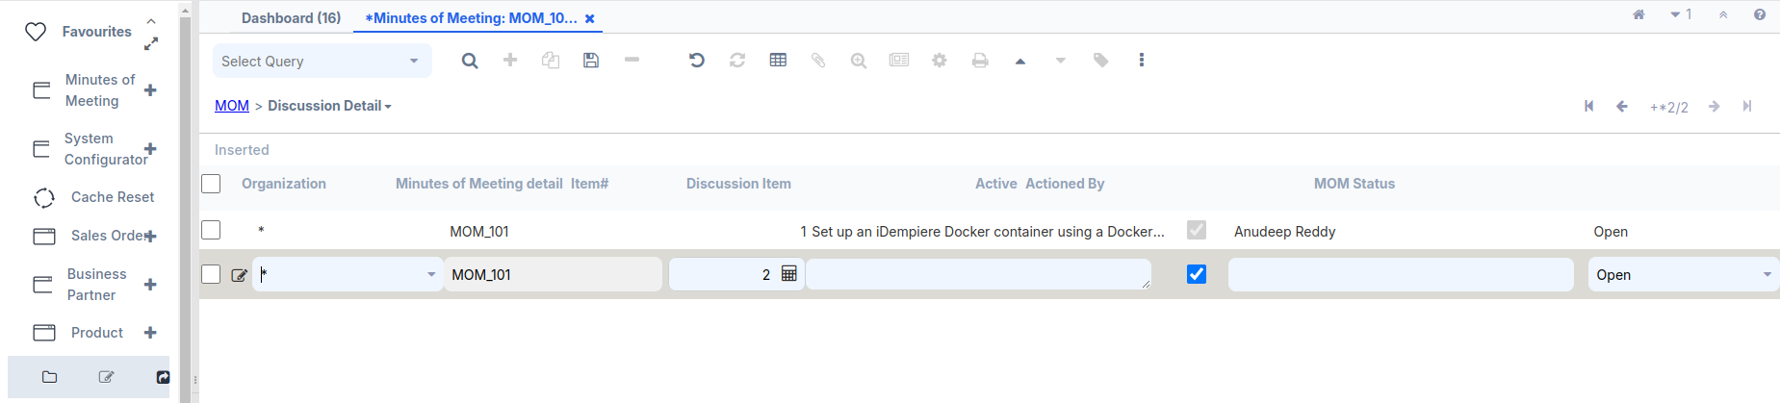

Process
A process is another way to execute business logic. Usage of a process is not limited to a window, tab, or field. It is not related to any table or column. You can write a process and link it with a button on a window/tab for further processing (for example, the Complete button on the Sales Order window). Moreover, we can write any business logic inside it and invoke it directly. All the items that appear with an icon in the Menu tree represent a process. This recipe will walk us through the steps to create a new process and invoke it. Here we are going to create a process, which prompts the user to select a MOM from the existing MOMs, and sends MOM-related mail to the participants of the selected MOM.

How to do it…
If the steps below are already performed in the Callout, then there is no need to do them again.
First, download the org.mom.calloutandprocessanddocaction JAR file. Then, use this JAR file within the OSGi framework.
Added Plug-in using OSGI frame work:-
A. Open your browser and go to: https://localhost:8443/
B. A new pop-up window will appear. On the top right, you will
see three tools. Click on the Settings tool.
C. use credential SuperUser/System
D. Click Install/Update at the top right.
E. A new pop-up window will open—check the first two checkboxes,
select your JAR file, and press the Install/Update button.
F. After the installation is complete, search for the plugin (mom).
G. Start the plugin, refresh the page, and the OSGi framework
setup will be completed.

Java Code:-
package org.mom.process;

import java.sql.PreparedStatement;
import java.sql.ResultSet;
import java.sql.SQLException;
import java.util.ArrayList;
import java.util.logging.Level;

import org.compiere.model.MClient;
import org.compiere.model.MUser;
import org.compiere.process.ProcessInfoParameter;
import org.compiere.process.SvrProcess;
import org.compiere.util.DB;
import org.compiere.util.EMail;
import org.mom.model.Mmom;

public class SendMOMMail extends SvrProcess {
private int m_c_mom_ID = -1;
private Mmom m_mom = null;
private int m_AD_User_ID = -1;
private MClient m_client = null;
private int m_AD_Client_ID = -1;
private MUser m_from = null;
private ArrayList<Integer> m_list = new ArrayList<Integer>();
private int m_counter = 0;
private int m_errors = 0;

@Override
protected void prepare() {
ProcessInfoParameter[] para = getParameter();
for (int i = 0; i < para.length; i++) {
String name = para[i].getParameterName();
if (para[i].getParameter() == null)
;
else if (name.equals("c_mom_ID"))
m_c_mom_ID = para[i].getParameterAsInt();
else
log.log(Level.SEVERE, "Unknown Parameter: " + name);
}
}

@Override
protected String doIt() throws Exception {
log.info("c_mom_ID=" + m_c_mom_ID);
m_mom = new Mmom(getCtx(), m_c_mom_ID, get_TrxName());
m_AD_User_ID = m_mom.getCreatedBy();
// Client Info
m_client = MClient.get(getCtx());
m_AD_Client_ID = m_client.getAD_Client_ID();
if (m_AD_Client_ID == 0)
throw new Exception("Not found @AD_Client_ID@");
if (m_client.getSMTPHost() == null || m_client.getSMTPHost().length() == 0)
throw new Exception("No SMTP Host found");
if (m_AD_User_ID > 0) {
m_from = new MUser(getCtx(), m_AD_User_ID, get_TrxName());
if (m_from.getAD_User_ID() == 0)
throw new Exception("No found @AD_User_ID@=" + m_AD_User_ID);
}
log.fine("From " + m_from);

if(m_AD_Client_ID > 0) {
m_client = new MClient(getCtx(), m_AD_Client_ID, get_TrxName());
if(m_AD_Client_ID == 0)
throw new Exception("No found @As_Client_ID=" + m_AD_Client_ID);
}
log.fine("From " + m_client);
long start = System.currentTimeMillis();
send2Participants();
return "@Created@=" + m_counter + ", @Errors@=" + m_errors + " - " +
(System.currentTimeMillis() - start) + "ms";
}

private void send2Participants() {
log.info("C_Mom_ID=" + m_c_mom_ID);
String sql = "SELECT a.ad_user_id " + "FROM adempiere.c_mom_participantsline a " +
"WHERE a.c_mom_id=?";
PreparedStatement pstmt = null;
try {
pstmt = DB.prepareStatement(sql, get_TrxName());
pstmt.setInt(1, m_c_mom_ID);
ResultSet rs = pstmt.executeQuery();
while (rs.next()) {
Boolean ok = sendIndividualMail(rs.getInt(1));
if (ok == null)
;
else if (ok.booleanValue())
m_counter++;
else
m_errors++;
}
rs.close();
pstmt.close();
pstmt = null;
} catch (SQLException ex) {
log.log(Level.SEVERE, sql, ex);
}
try {
if (pstmt != null)
pstmt.close();
} catch (SQLException ex1) {
}
pstmt = null;
}

private Boolean sendIndividualMail(int AD_User_ID) {
Integer ii = new Integer(AD_User_ID);
if (m_list.contains(ii))
return null;
m_list.add(ii);
MUser to = new MUser(getCtx(), AD_User_ID, null);
String message = "Hi " + to.getFirstName() + "\n " + m_mom.getName()
+ " has been updated in the system!\nThanks";
String subject = "MOM : " + m_mom.getName();

// Validate sender email
if (m_client.getRequestEMail() == null || m_client.getRequestEMail().isEmpty()) {
System.out.println("Sender email is not configured: " + m_client.getName());
return Boolean.FALSE;
}

// Validate recipient email
if (to.getEMail() == null || to.getEMail().isEmpty()) {
System.out.println("Recipient email is not configured: " + to.getName());
return Boolean.FALSE;
}

EMail email = m_client.createEMailFrom(m_client.getRequestEMail(), to.getEMail(), subject, message,false);
if (email == null) {
System.out.println("Failed to create email. Check SMTP configuration and email addresses.");
return Boolean.FALSE;
}
email.setSubject(subject);
email.setMessageText(message);
if (!email.isValid() && !email.isValid(true)) {
log.warning("NOT VALID - " + email);
to.setIsActive(false);
to.addDescription("Invalid EMail");
to.save();
return Boolean.FALSE;
}
boolean OK = EMail.SENT_OK.equals(email.send());
if (OK)
log.fine(to.getEMail());
else
log.warning("FAILURE - " + to.getEMail());
addLog(0, null, null, (OK ? "@OK@" : "@ERROR@") + " - " + to.getEMail());
return new Boolean(OK);
}
}
- Log in as System/System with the System Administrator role.
- Go to the Menu | Application Dictionary | Reference window Or Enter the Search bar, go to the Reference window and create a new reference, MOM, as shown in the following screenshot:
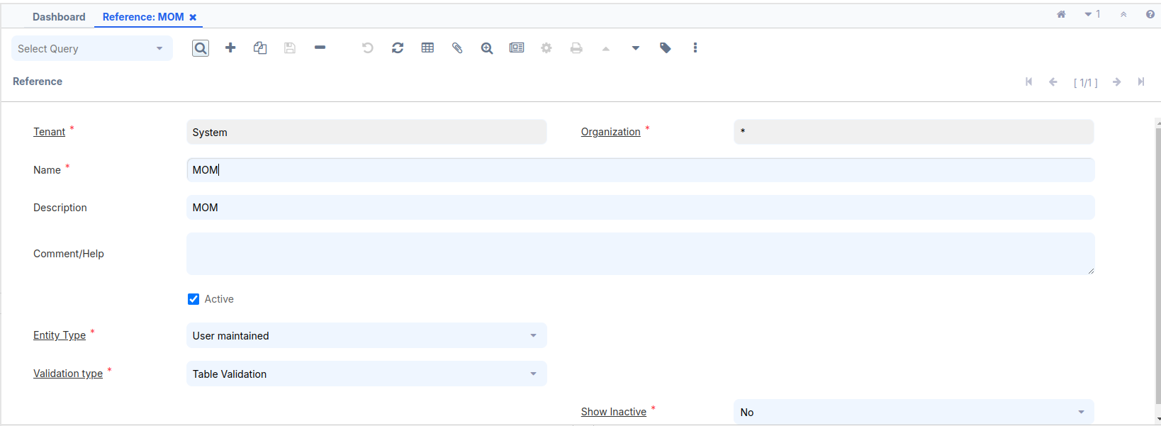

- Go to the Table Validation tab and create a new record for the c_mom table and the c_mom_ID column, as shown in the following screenshot:

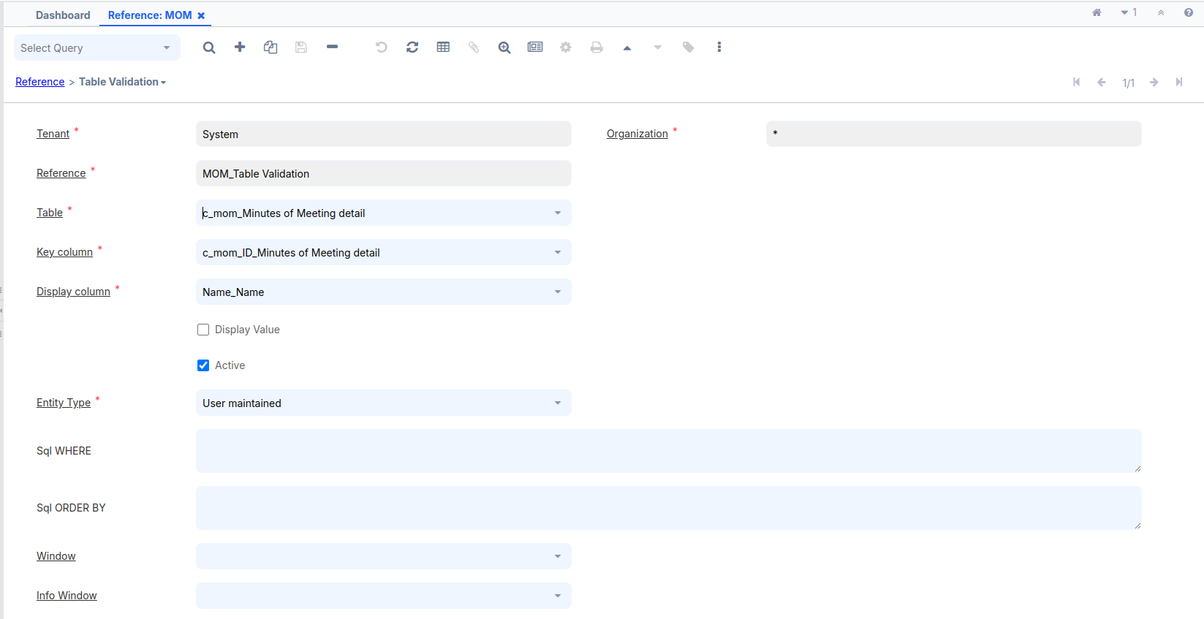

- Go to the Menu | Application Dictionary | Report & Process window and create a new record—Send MOM Mail. In the Classname, mention the org.mom.process.SendMOMMail process name, as shown in the following screenshot:
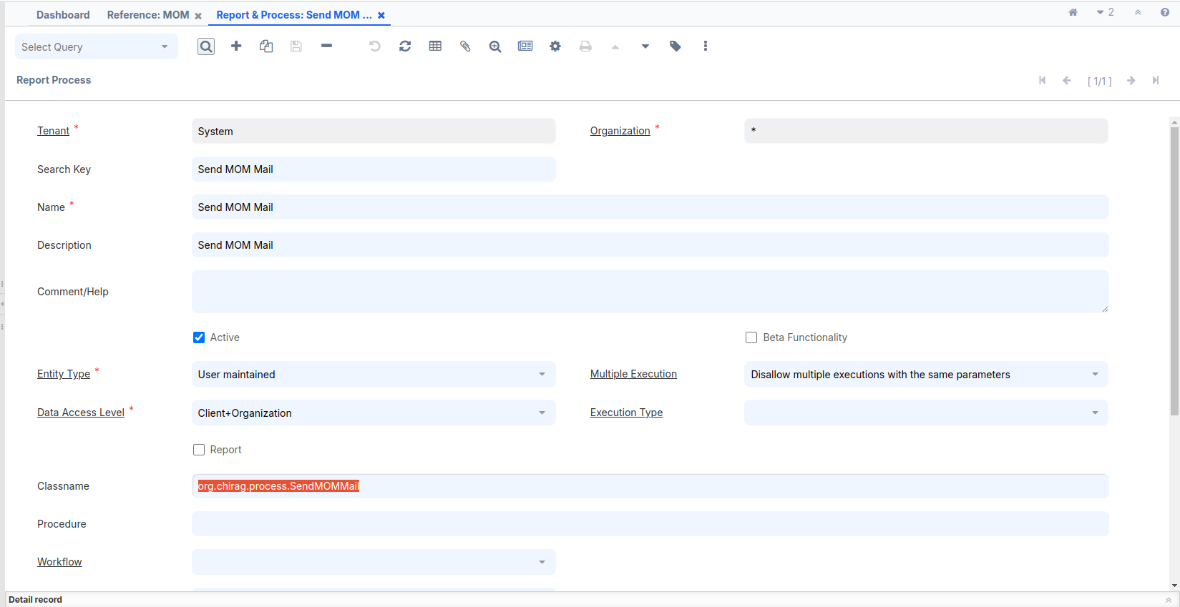

- Go to the Parameter tab to create a process parameter where we can select the MOM for which e-mail needs to be sent to their participants.
- Create a new parameter, as shown in the following screenshot, with the following important details:
- DB Column Name: c_mom_ID
- System Element: c_mom_ID
- Reference: Table
- Reference Key: MOM (this is the reference that we created in the previous steps)
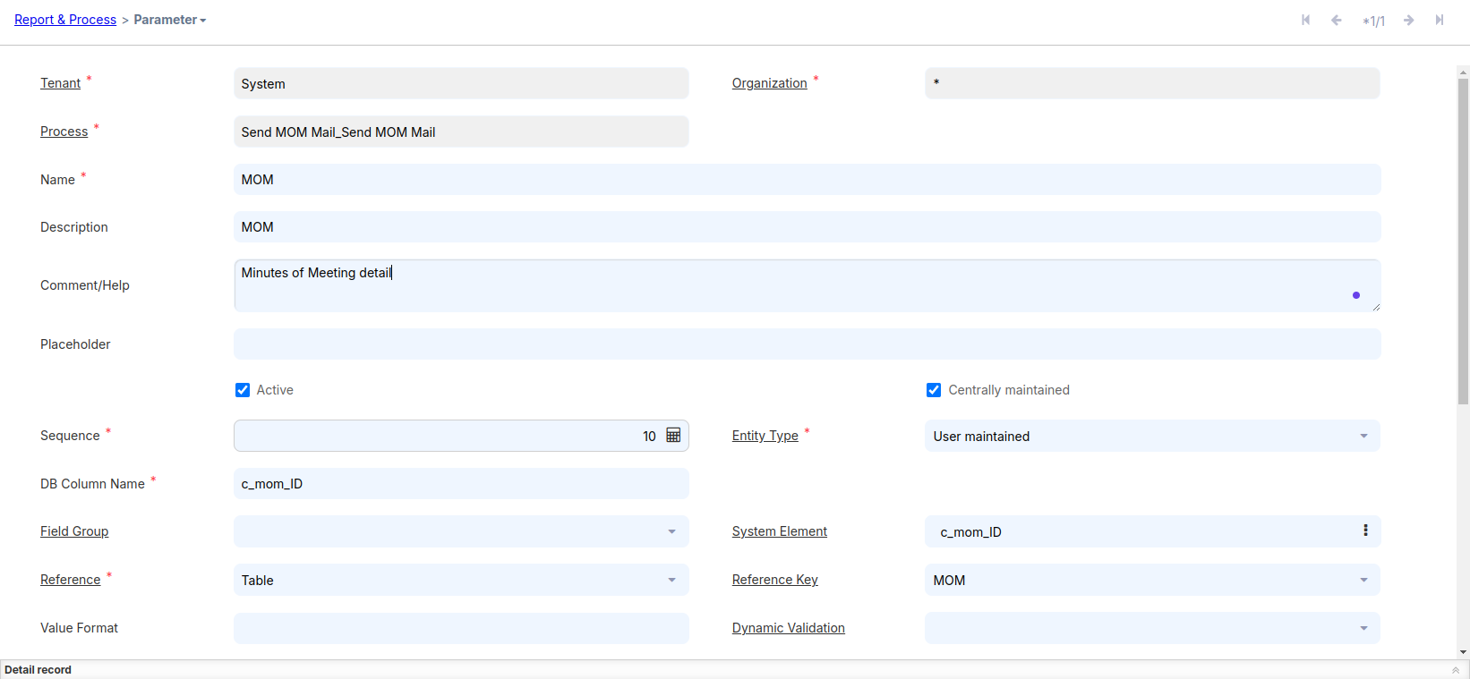
Save the record.
- Go to the Menu | System Admin | General Rules | System Rules | Menu window and create a new menu item—Send MOM Mail. Add this menu item to the MOM node, as shown in the following screenshot:
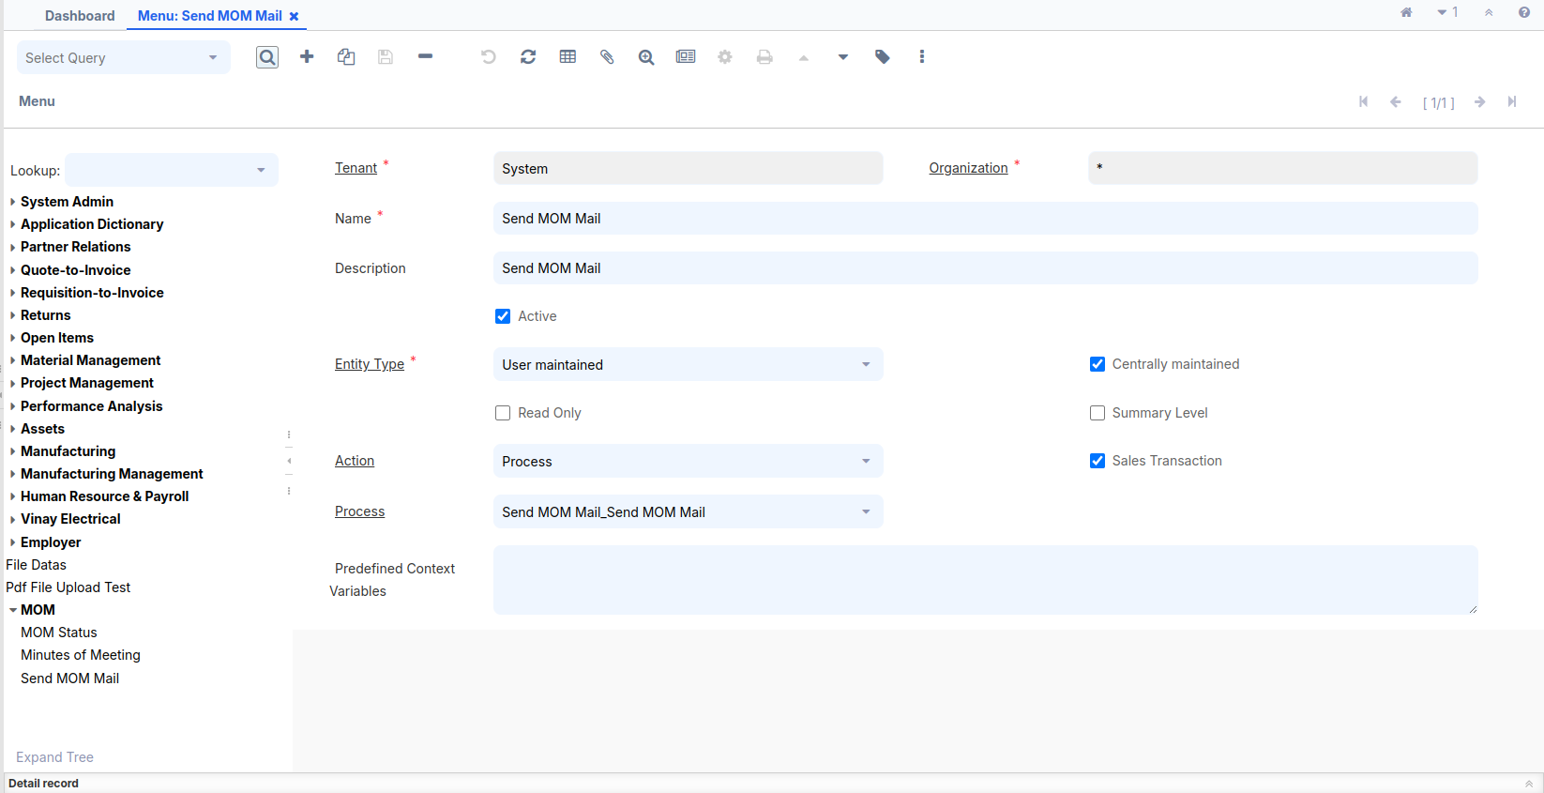
After saving the record, go to the search bar, enter Cache Reset, and click OK.
- Log out and log in as GardenAdmin/GardenAdmin with the GardenWorld Admin role.

- Enter the Search bar,Go to the Tenant window and fill all required fields below mention, click on the Test EMail button. If everything is correct, you will see a success message, as shown in the following screenshot:
Before pressing the Test Email button, ensure that some
important fields are filled; otherwise, an error message will
appear instead of a success message.
- Mail Host = smtp.gmail.com
- SMTP Port = 587
- Request EMail = chiragrathiji111@gmail.com
- Request User = chiragrathiji111@gmail.com
- Request Folder = request
- Check the SMTP Authentication Check Box
- Request User Password = Need to generate

Steps to Enable 2-Step Verification and Generate an App Password:
- Access Your Google Account:
  - Open your email account.
  - Click on your Google account icon (profile picture) in the top-right corner.
  - From the dropdown menu, click Manage your Google Account. This will open a new page within the same window.
- Enable 2-Step Verification:
  - On the new page, locate the Security option in the left-side navigation panel and click on it.
  - Scroll down to the 2-Step Verification section in the middle of the page.
  - Check if 2-Step Verification is enabled. If it is not, follow the steps to enable it by verifying your phone number or another verification method.
- Generate an App Password:
  - After enabling 2-Step Verification, return to the Security section.
  - Scroll down to the App Passwords option and click on it.
  - You will be prompted to enter your Google account password.
  - On the App Passwords page, select an app or use case (e.g., Mail or Custom App) and generate the app password.
  - A 16-digit password will be displayed. Copy this password and save it securely in a text editor or password manager.
  - Note: Once you close this page, you cannot retrieve the password again. Make sure to save it securely before leaving the page.
- Use the App Password:
  - Use the generated 16-digit password in place of your normal Google account password when setting up the selected app or service.
Copy and paste this 16-digit password into the Request User Password field and click Save.
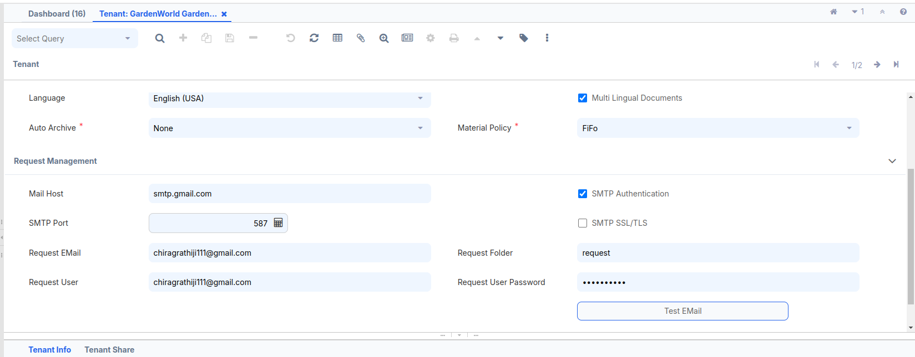

Click the Test Email button, and in the new pop-up window, press OK to see the Successful message.
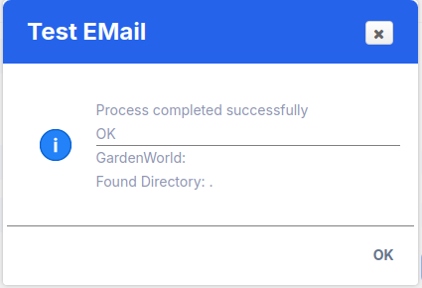

- Click on the Send MOM Mail process. It will prompt you to select a MOM, as shown in the following screenshot:
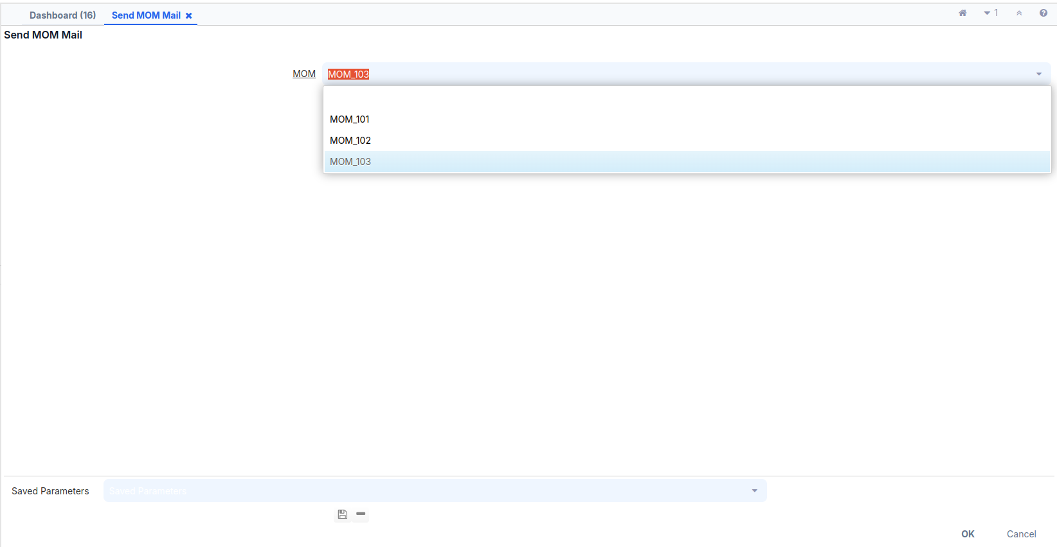
- Select an MOM from the drop-down list and click on the OK button. This will send the e-mail and present the status, finally, as shown in the following screenshot:
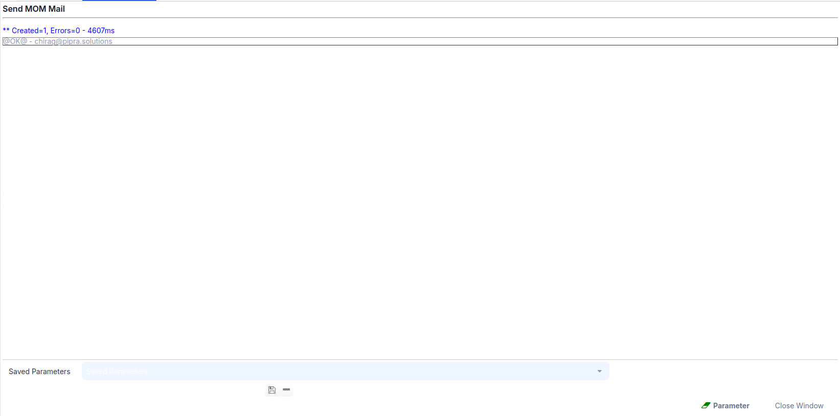

- Check your mailbox to see if you have received e-mail with the MOM details, as shown in the next screenshot:
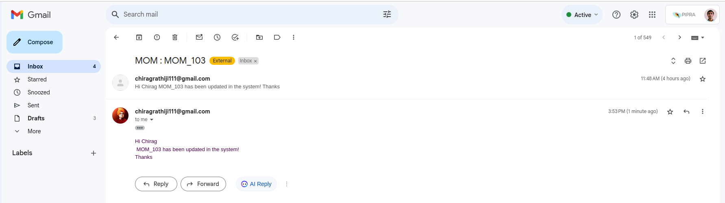
If you encounter an error, it means the User does not have an Email address. To check this:
- Verify which user you selected, such as the Minute of Meeting record. Below it, navigate to the Participants tab, open the record, and check the User name.
- Then, go to the User window through the search bar and check the email address for that user.

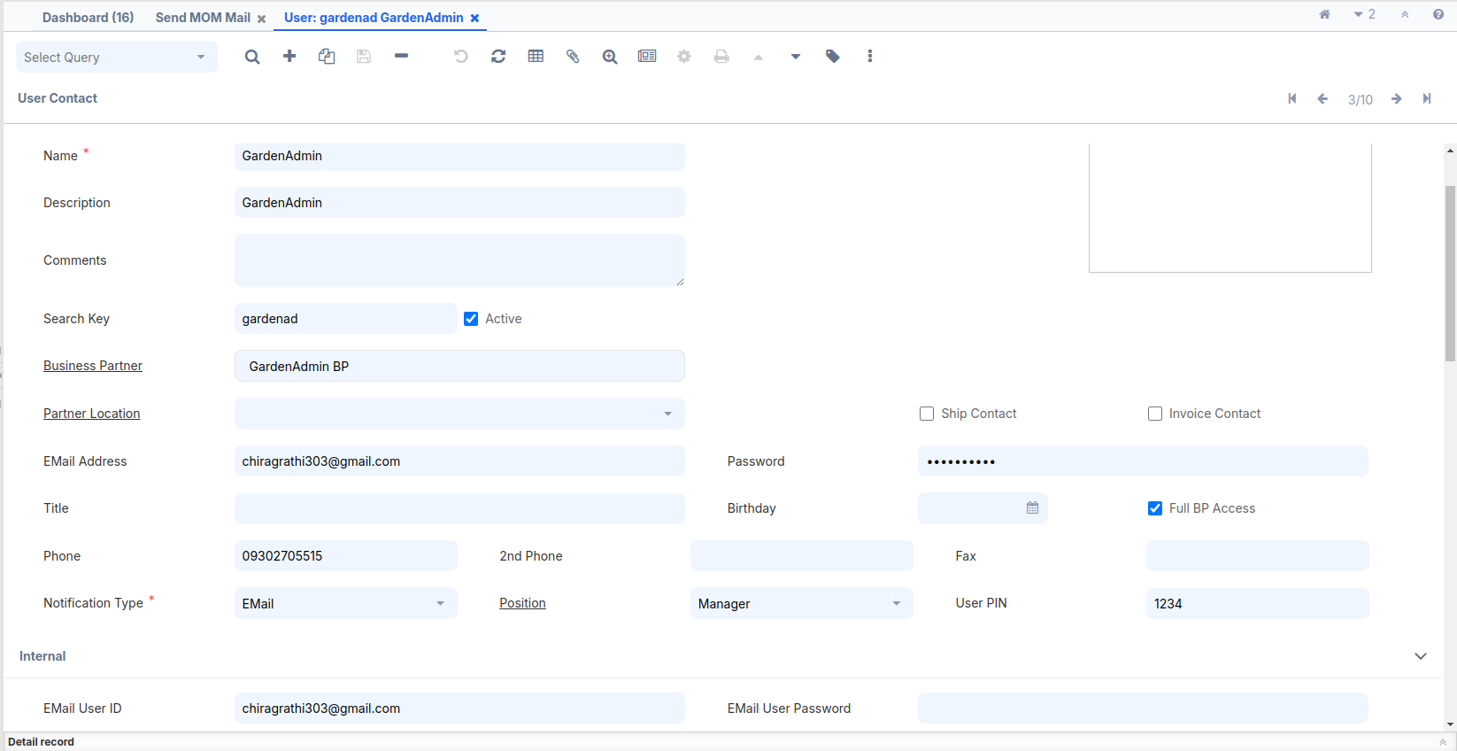

Report
The main purpose of creating a report is to display specific data according to user requirements. For example, if a window has 10 fields, but we want to show only 5 fields, and filter the data based on certain parameters and date criteria, we can create the report accordingly.
iDempiere supports creating reports in two ways:-
- Create a report view table based on an existing table.
- Use a SQL query to create a Jasper report.
Create a report view table based on an existing table:-
If we want to create a report using the Report View feature, follow these steps:

How to do it…

- Create the following database view:
CREATE VIEW adempiere.c_mom_v AS
SELECT
a.*,
b.item_nbr,b.discussion_desc,b.actionedby AS actioned_by,b.c_mom_status_id,
c.ad_user_id AS participant,c.company,
d.name AS status
FROM adempiere.c_mom a
JOIN adempiere.c_mom_discussionline b ON a.c_mom_id=b.c_mom_id
JOIN adempiere.c_mom_participantsline c ON c.c_mom_id=b.c_mom_id
JOIN adempiere.c_mom_status d ON b.c_mom_status_id=d.c_mom_status_id;
- Log in as System/System with the System Administrator role.
- Open Application Dictionary | Table and then the Column window. Then create a new record for the newly created view— c_mom_v and check the View check box.
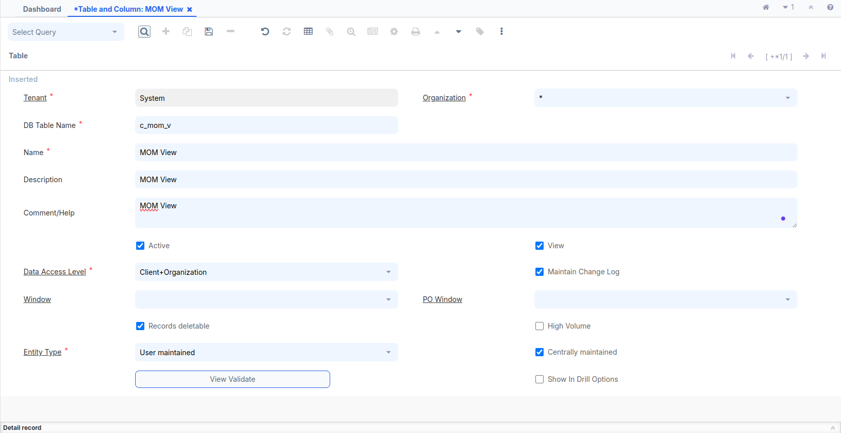
- Click on the Create Columns from DB button and verify that all the columns are created on the Column tab.
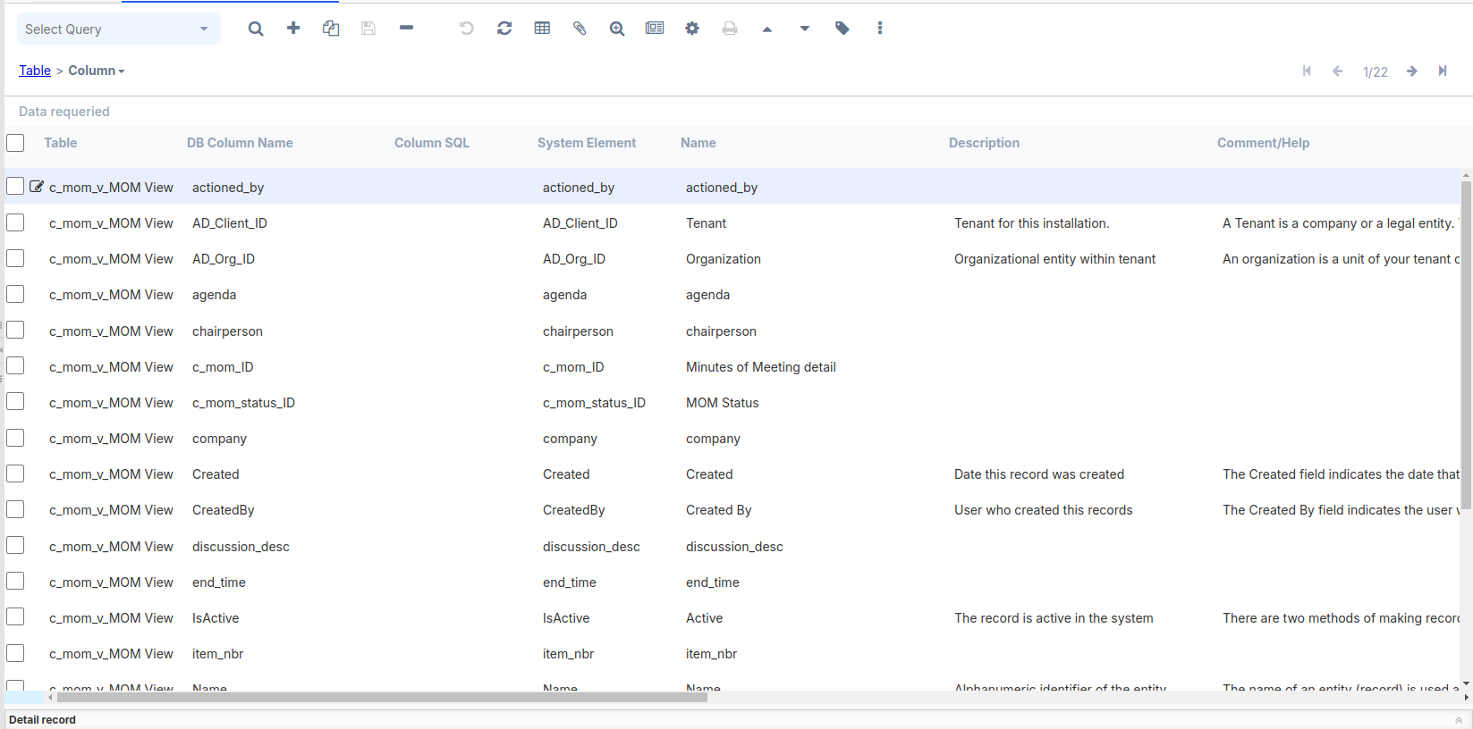
- Open the Application Dictionary | Report View window and create a new record using the newly created table in the dictionary—
MOM View and enter table field c_mom_v .
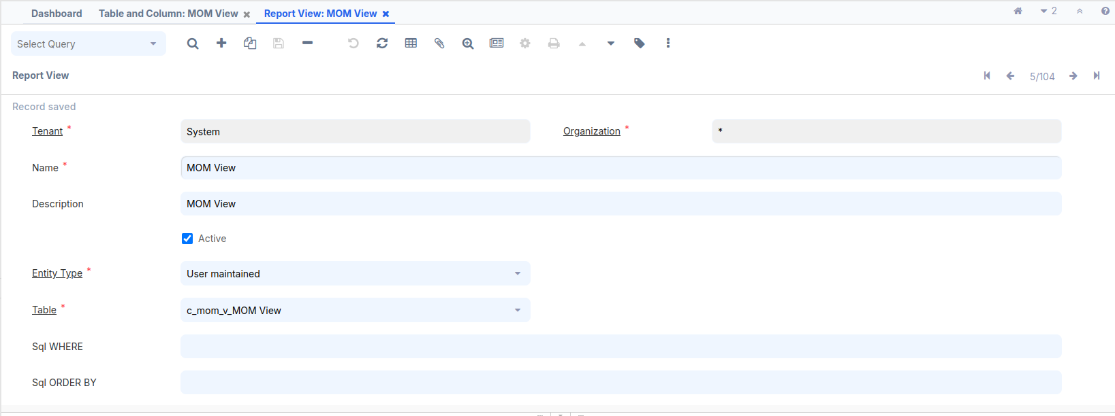
- Open the Application Dictionary | Report & Process window, create a report entry,and select MOM View, which was created in the previous step, as the Report View.
Name = MOM Report with View
Entity Type = User maintained
Data Access Level = Client+Organization
Check the Report check box
Report View = MOM View
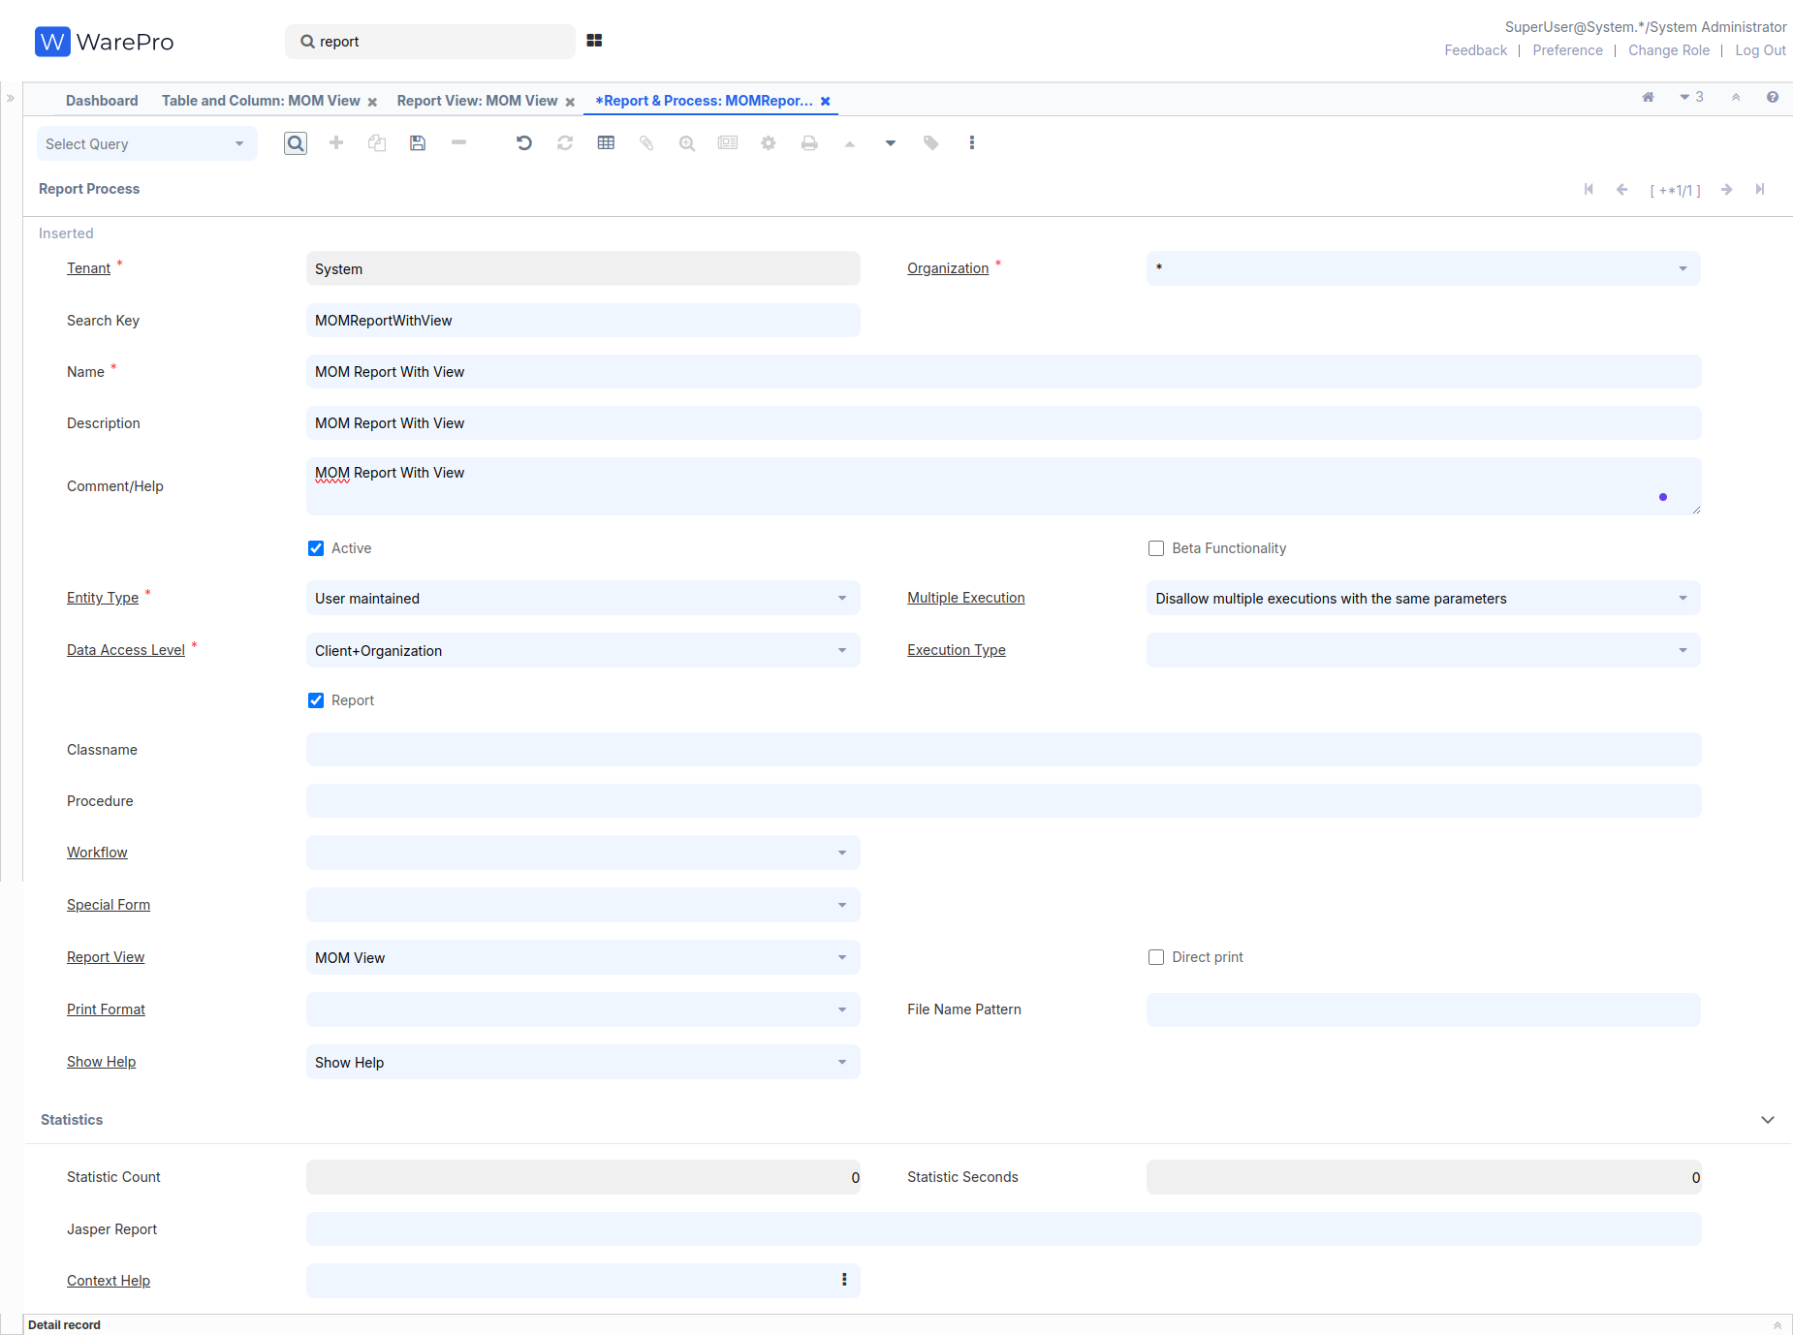
- Verify the access to the report on the Report Access tab. By default, all the roles are given access. You may review the list and grant access to the roles according to your need.
- Now, go to the Menu | System Admin | General Rules | System Rules | Menu window and create a new menu node for the report under the MOM menu
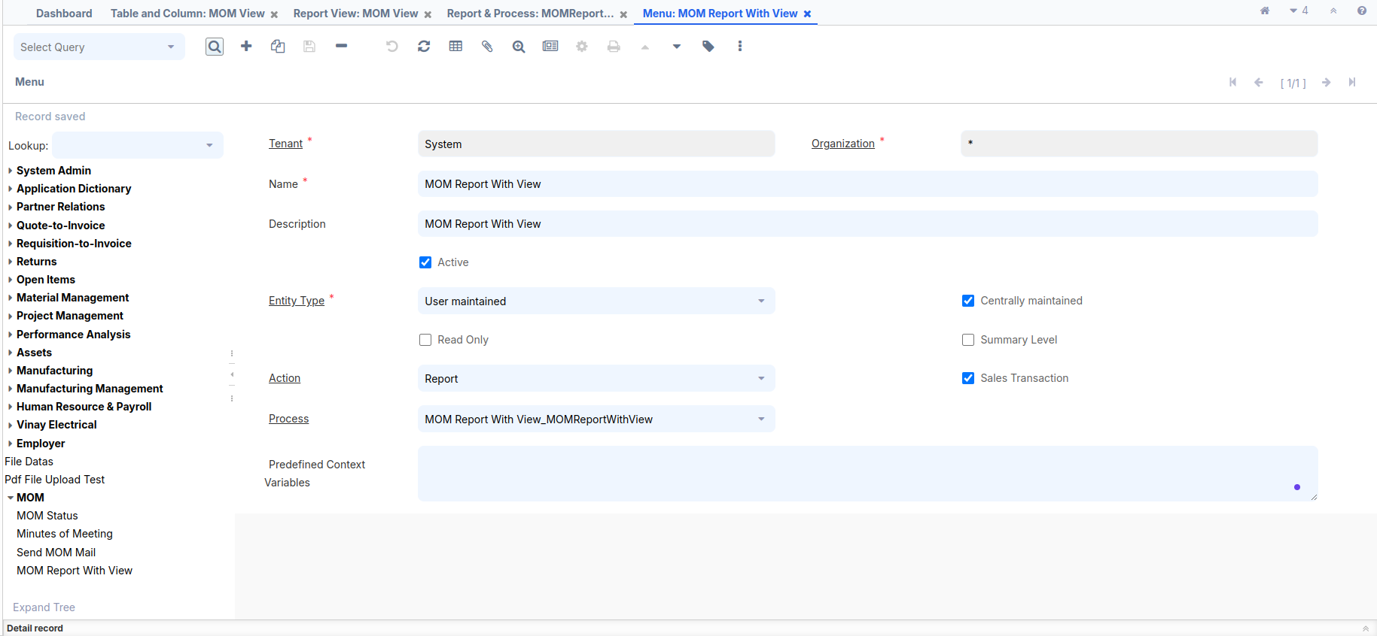
- Log out and log in as GardenAdmin/GardenAdmin with the GardenWorld Admin role. You shall see the newly added menu item under the MOM menu.
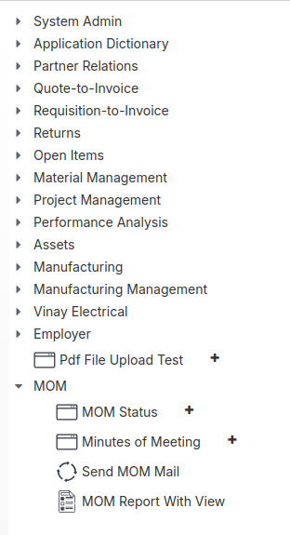

- Click on the MOM Report With View menu and run the report. You shall get the following report output, which indicates that we are able to create a report from a database view.
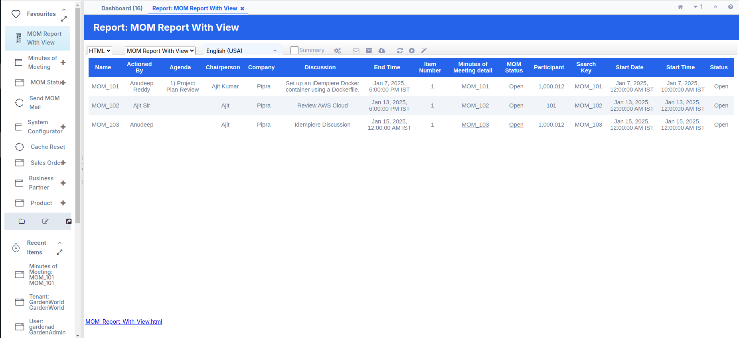

Doc Action Setup

Once the Doc Action is completed, the record cannot be edited.
Additionally, you cannot create or edit any tabs associated with the record after the Doc Action.

How to do it…
Please follow (Create the following table in your Adempiere schema) heading for create or alter table query,previously already guided.
- First, update the table query for Doc Action setup:-
ALTER TABLE adempiere.c_mom
ADD COLUMN docaction CHAR(2) NOT NULL DEFAULT 'CO'::bpchar,
ADD COLUMN DocStatus CHAR(2) NOT NULL DEFAULT 'DR'::bpchar,
ADD COLUMN processing CHAR(1) DEFAULT 'N'::bpchar,
ADD COLUMN processed character(1) NOT NULL DEFAULT 'N'::bpchar,
ADD COLUMN c_doctype_id numeric(10,0) NOT NULL DEFAULT 0,
ADD COLUMN c_doctypetarget_id numeric(10,0) NOT NULL DEFAULT 0,
ADD COLUMN isapproved character(1) NOT NULL DEFAULT 'Y'::bpchar;
- Log in as System/System with the System Administrator role.
- Open Application Dictionary | Table and Column window. Locate and select the existing record for — c_mom.
- Click on the Create Columns from DB button and verify that all new columns are created on the Column tab
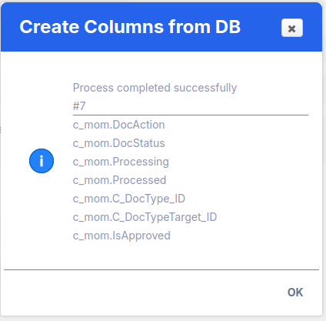
- Some Column fields have updated to our requirement :
- C_DocType_ID : Default Logic = 0,Check the Updatable Check Box
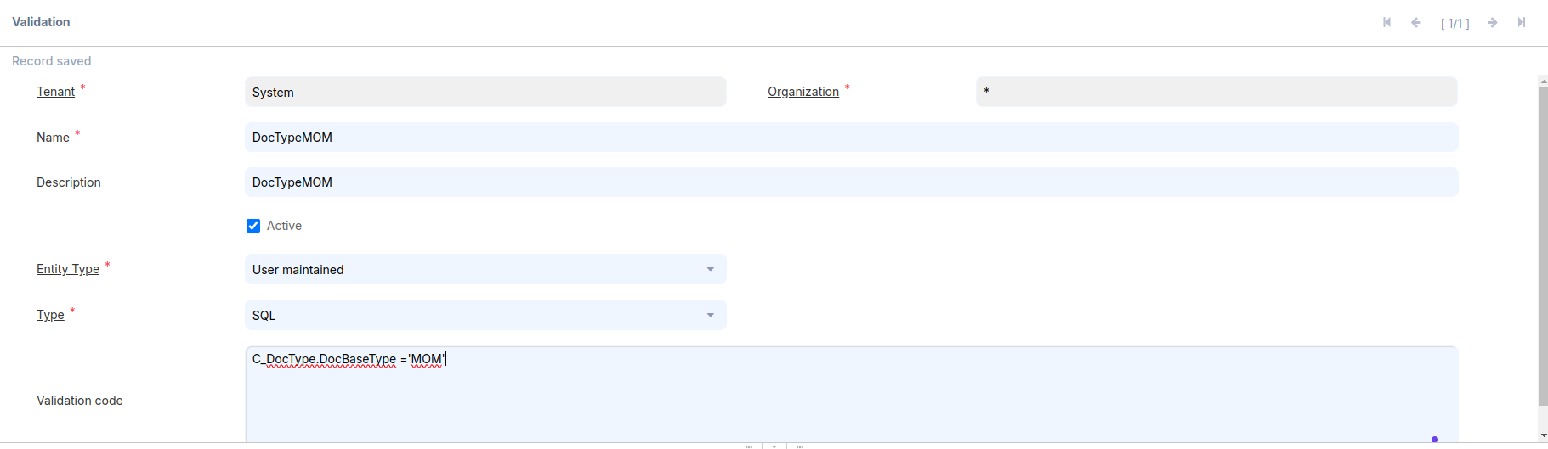
- C_DocTypeTarget_ID : Reference = Table,
Reference Key = C_DocType,
Uncheck the Updatable Check Box,
Dynamic Validation = DocTypeMOM
Click on the Dynamic Validation field, create a new Dynamic Validation, and fill in the mandatory fields.
Name = DocTypeMOM
Validation Code = C_DocType.DocBaseType ='MOM'
(MOM This value using our validation and note this key required 3 character)
- DocStatus : Reference = List,
Reference Key = _Document Status,
Default Logic = DR
- Processed : Uncheck the Updatable Check Box
- Processing : Reference = Button,
Process = Process MOM
(This Process created flow show in below)
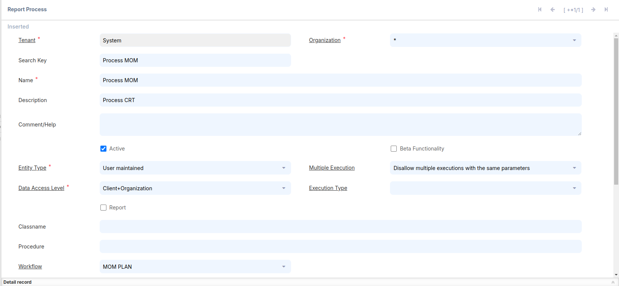
- DocAction : Reference = Button,
Reference Key = _Document Action,
Default Logic = CO
Process = Process MOM(Create a new Process and select)
Create a Process and fill mandatory field
Search Key = Process MOM
Name = Process MOM
Entity Type = User maintained
Data Access Level = Client + Organization
Workflow = MOM Plan
(Below will be created)
- Work Flow:-
Create a Work Flow and fill mandatory field
Search Key = MOM PLAN
Name = MOM PLAN
Workflow Type = Document Process
Table = c_mom_Minutes of Meeting Detail
Data Access Level = All
Author = Chirag Rathi (Write any name)

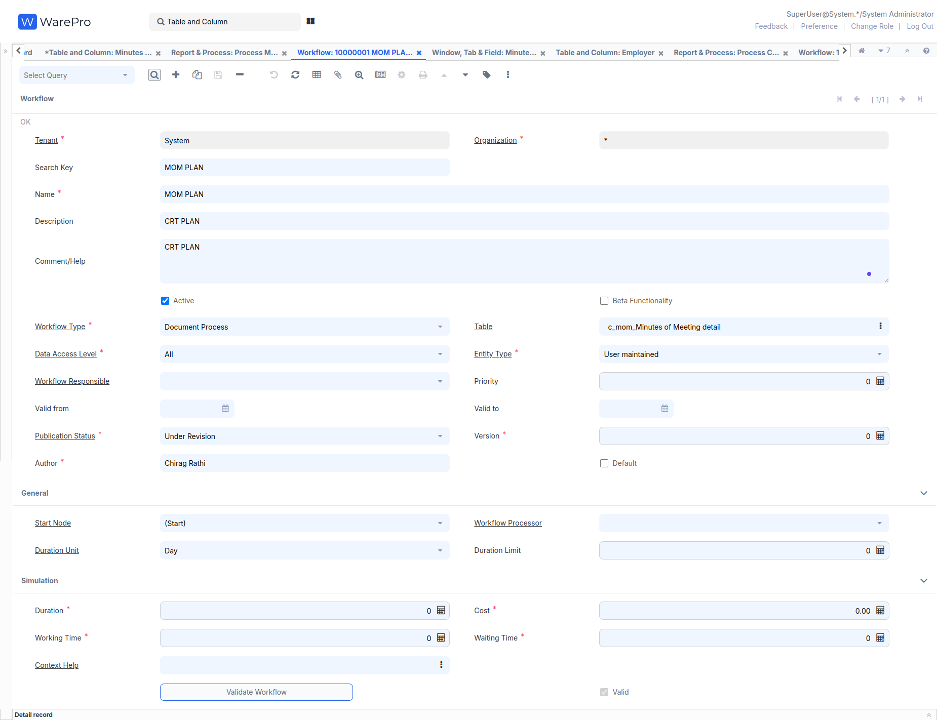
At the bottom left, go to the Node tab, enter it, and create four records:-
- Name = (Start), Search Key = (Start), Entity Type - Dictionary, Action = Wait (Sleep)
- Name = (DocPrepare), Search Key = (DocPrepare),
Entity Type - Dictionary, Action = Document Action,
Document Action = Prepare
- Name = (DocComplete), Search Key = (DocComplete),
Entity Type - Dictionary, Action = Document Action,
Document Action = Complete
- Name = (DocAuto), Search Key = (DocAuto),
Entity Type - Dictionary, Action = Document Action,
Document Action = <None>
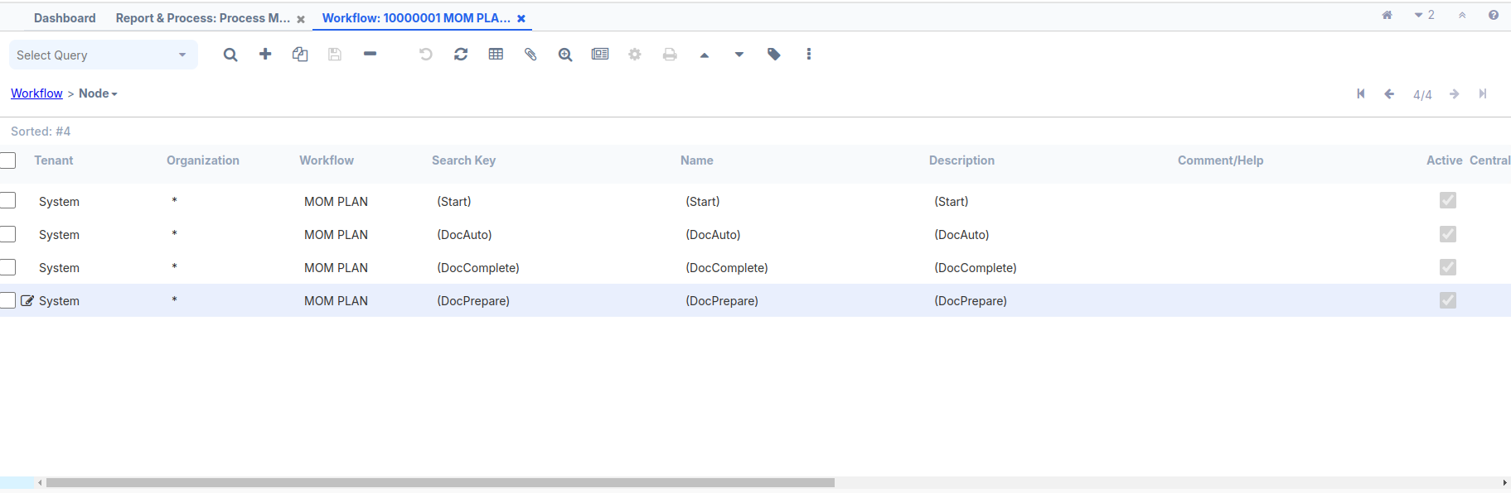
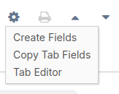
Go to the main Workflow screen, select the Start Node = (Start) and then click Save
After creating the Workflow, select it on the Process screen and click Save.
After creating the Process, select it on the DocAction Column screen
Toolbar Button = Both and click Save.
After creating the Process then fill the Processing Column and click Save.
6. Open Application Dictionary | Window,Tab and Field window.
Locate and select the existing record for — Minutes of Meeting.
7. Select the MOM/Minutes of Meeting tab and make the necessary edits.
In the bottom-left corner, press Ctrl + O or
click the Settings icon.
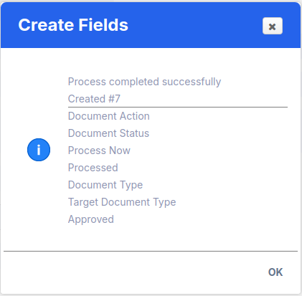
8. Review the Field Sequence tab and make the required changes to the sequence, as shown in the following screenshot:
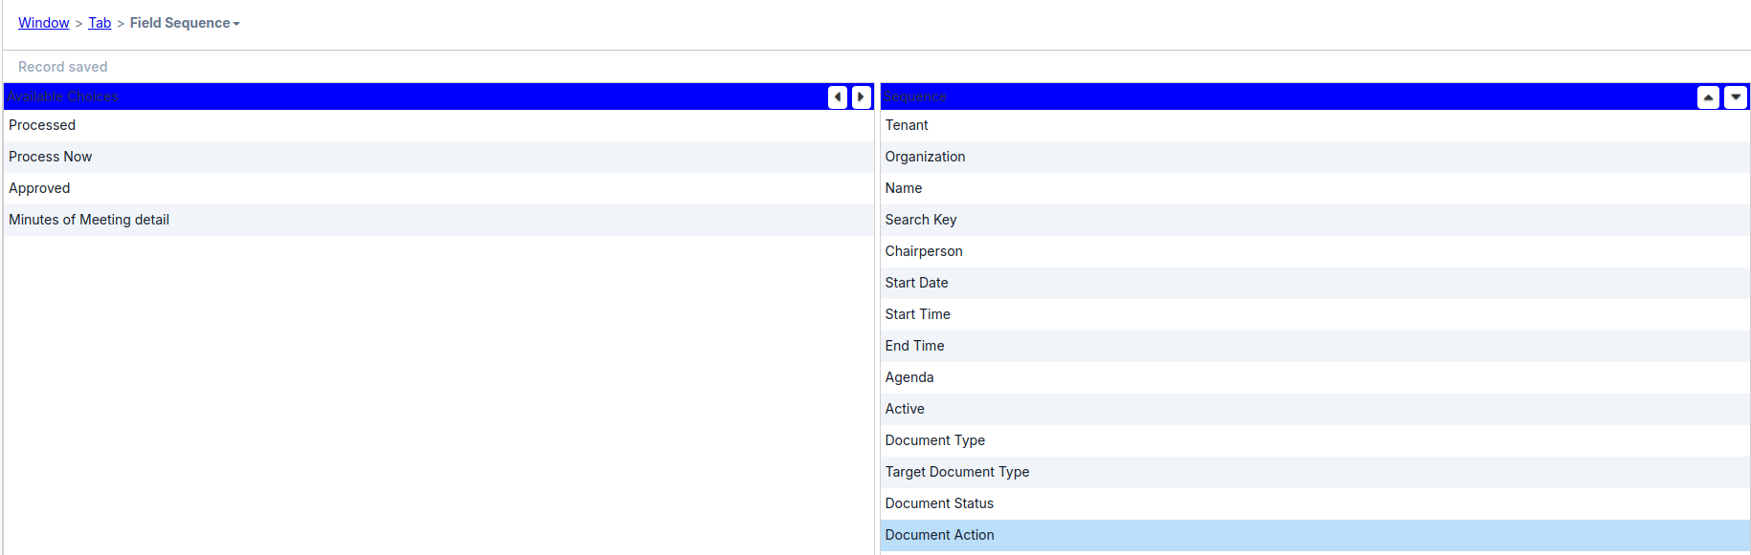

9. Some Field value Updated:-
Document Type : Check the Read Only Check Box, X Position = 1
Target Document Type : X Position = 4
Document Status : Field Group = Status
Document Action : Field Group = Status, X Position = 5
10. Create A Custom Document :-
Use the search bar at the top left, type Reference, then enter C_DocType DocBaseType in the Name field and press Enter At the bottom left, go to the List Validation tab, enter it, and create a new record:
Search Key = MOM(This key corresponds to the dynamic validation inside C_DocTypeTarget_ID),
Name = Minutes of Meeting and
Entity Type - Dictionary
click Save.
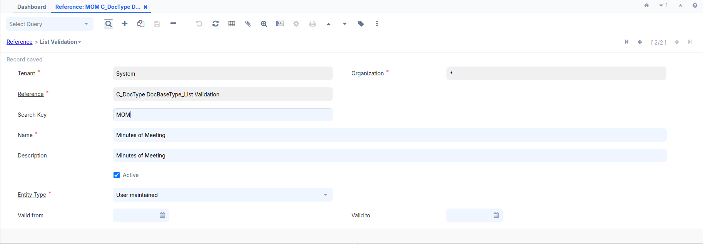
11. Log out and log in as GardenAdmin/GardenAdmin with the
GardenWorld Admin role.
12. Use the search bar at the top left and enter Document Type and create
a new document
Name = Minutes of Meeting
Print Text = Minutes of Meeting
GL Category = None
Document Base Type = Minutes of Meeting
(Select the same record while logged in as System for creating it)click save.
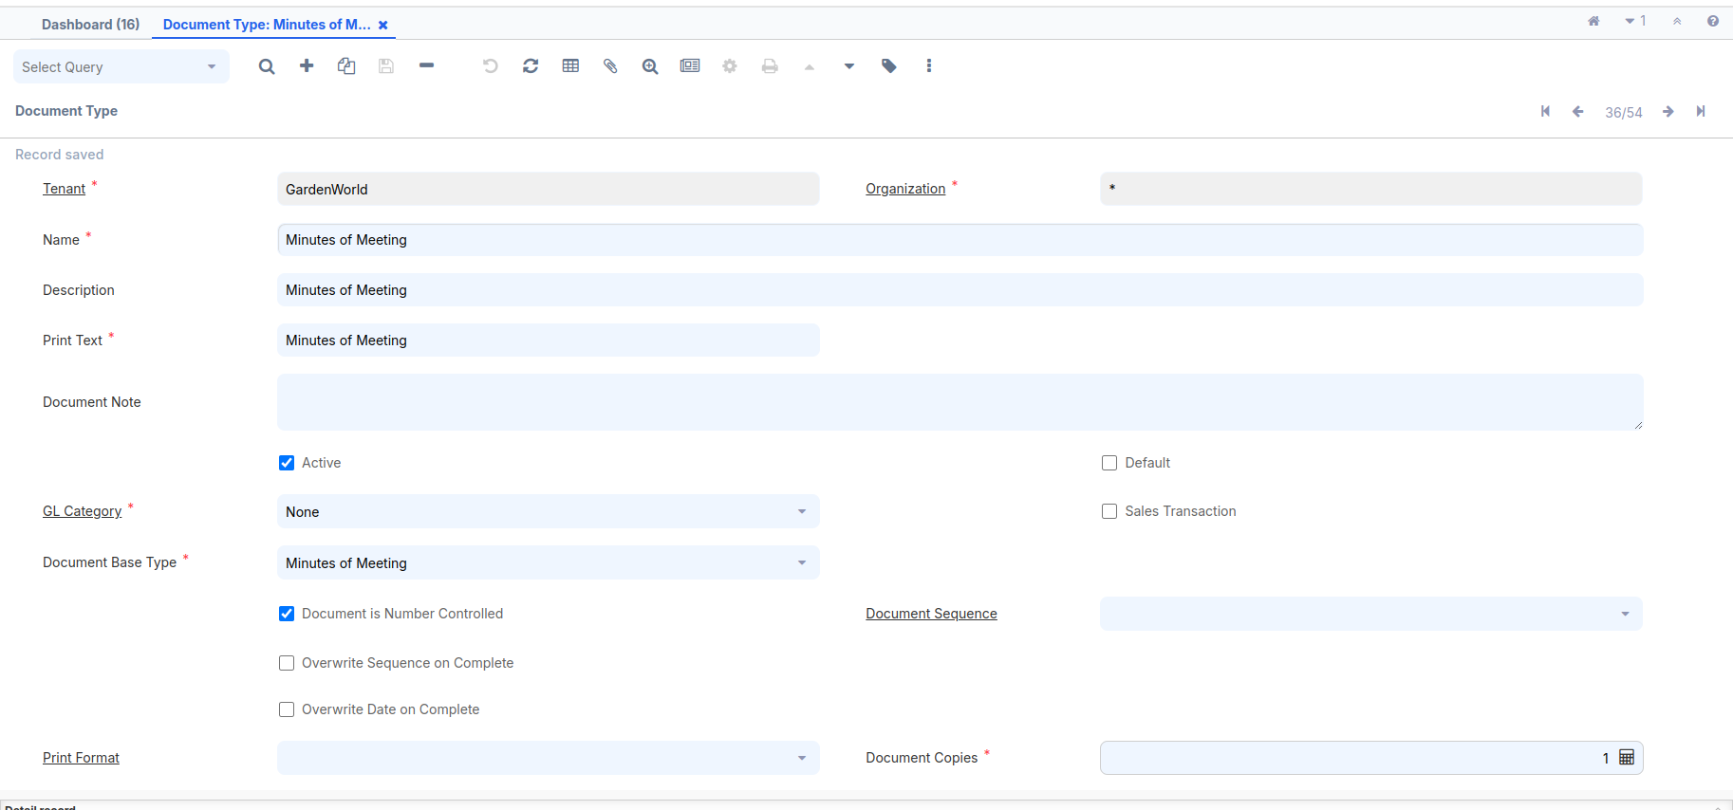
13. Use the search bar at the top left and enter Workflow Editor
Select the Workflow name(Select the same record while logged in as System for creating it) from the top-left toolbar
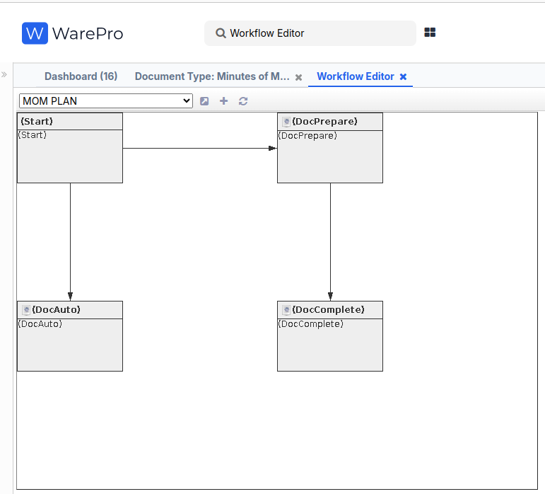
14. Create a new Minute of Meeting record and add a screenshot after the Doc Action.
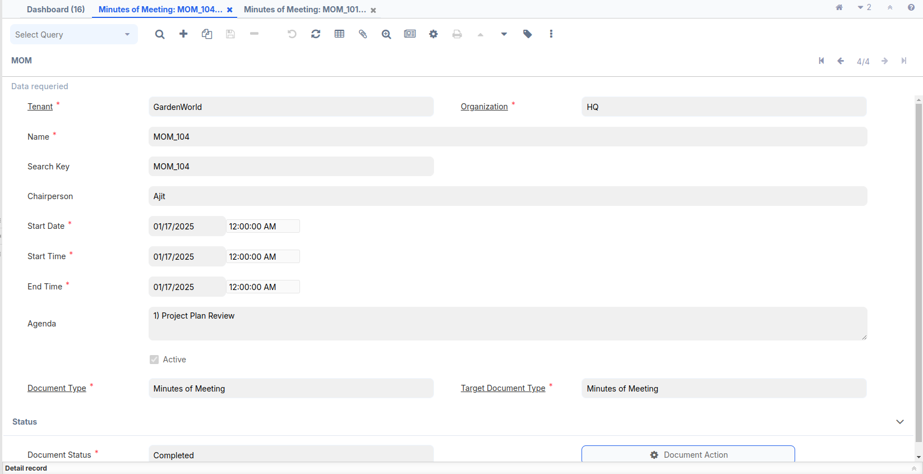

Java Code :-
DocumentFactory:-
package org.mom.doc.factory;

import java.sql.PreparedStatement;
import java.sql.ResultSet;
import java.util.logging.Level;
import org.adempiere.base.IDocFactory;
import org.compiere.acct.Doc;
import org.compiere.model.MAcctSchema;
import org.compiere.model.MTable;
import org.compiere.util.CLogger;
import org.compiere.util.DB;
import org.compiere.util.Env;
import org.mom.model.DocMOM;
import org.mom.model.MOMModel;
import org.mom.model.Mmom;

public class DocumentFactory implements IDocFactory{

CLogger log = CLogger.getCLogger(DocumentFactory.class);
@Override
public Doc getDocument(MAcctSchema as, int AD_Table_ID, int Record_ID, String trxName) {

String tableName = MTable.getTableName(Env.getCtx(), AD_Table_ID);
Doc doc = null;
StringBuffer sql = new StringBuffer("SELECT * FROM ")
.append(tableName)
.append(" WHERE ").append(tableName).append("_ID=? AND Processed='Y'");
PreparedStatement pstmt = null;
ResultSet rs = null;
try
{
pstmt = DB.prepareStatement (sql.toString(), trxName);
pstmt.setInt (1, Record_ID);
rs = pstmt.executeQuery ();
if (rs.next ())
{
doc = getDocument(as, AD_Table_ID, rs, trxName);
}
else
log.severe("Not Found: " + tableName + "_ID=" + Record_ID);
}
catch (Exception e)
{
log.log (Level.SEVERE, sql.toString(), e);
}
finally
{
DB.close(rs, pstmt);
rs = null;
pstmt = null;
}
return doc;
}

@Override
public Doc getDocument(MAcctSchema as, int AD_Table_ID, ResultSet rs, String trxName) {
Doc doc = null;

String tableName = MTable.getTableName(Env.getCtx(), AD_Table_ID);
if(tableName.equals(MOMModel.Table_Name)) {
return new DocMOM(as, getClass(), rs, tableName, trxName);
}
if (doc == null)
log.log(Level.SEVERE, "Unknown AD_Table_ID=" + AD_Table_ID);
return doc;
}
}

ModelFactory :-
package org.mom.doc.factory;

import java.sql.ResultSet;
import org.adempiere.base.IModelFactory;
import org.compiere.model.PO;
import org.mom.model.MOMModel;

public class ModelFactory implements IModelFactory{

@Override
public Class<?> getClass(String tableName) {
if (tableName.equalsIgnoreCase(MOMModel.Table_Name))
return MOMModel.class;
return null;
}

@Override
public PO getPO(String tableName, int Record_ID, String trxName) {
if(tableName.equalsIgnoreCase(MOMModel.Table_Name))
return new MOMModel(null,Record_ID,trxName);
return null;
}

@Override
public PO getPO(String tableName, ResultSet rs, String trxName) {
if(tableName.equalsIgnoreCase(MOMModel.Table_Name))
return new MOMModel(null,rs,trxName);
return null;
}
}

DocMom:-
package org.mom.model;

import java.math.BigDecimal;
import java.sql.ResultSet;
import java.util.ArrayList;

import org.compiere.acct.Doc;
import org.compiere.acct.Fact;
import org.compiere.model.MAcctSchema;

public class DocMOM extends Doc{

public DocMOM(MAcctSchema as, Class<?> clazz, ResultSet rs, String defaultDocumentType,
String trxName) {
super(as, MOMModel.class, rs, null, trxName);
// TODO Auto-generated constructor stub
}

@Override
protected String loadDocumentDetails() {
// TODO Auto-generated method stub
return null;
}

@Override
public BigDecimal getBalance() {
// TODO Auto-generated method stub
return BigDecimal.ZERO;
}

@Override
public ArrayList<Fact> createFacts(MAcctSchema as) {
ArrayList<Fact> facts = new ArrayList<Fact>();
return facts;
}
}

MOMModel :-
package org.mom.model;

import java.io.File;
import java.math.BigDecimal;
import java.sql.ResultSet;
import java.util.Properties;

import org.compiere.process.DocAction;
import org.compiere.process.DocOptions;
import org.compiere.process.DocumentEngine;

public class MOMModel extends X_c_mom implements DocAction,DocOptions{

public MOMModel(Properties ctx, int c_mom_ID, String trxName) {
super(ctx, c_mom_ID, trxName);
// TODO Auto-generated constructor stub
}

public MOMModel(Properties ctx, ResultSet rs, String trxName) {
super(ctx, rs, trxName);
// TODO Auto-generated constructor stub
}

private static final long serialVersionUID = 1L;

@Override
public int customizeValidActions(String docStatus, Object processing, String orderType, String isSOTrx,
int AD_Table_ID, String[] docAction, String[] options, int index) {
if (options == null)
throw new IllegalArgumentException("Option array parameter is null");
if (docAction == null)
throw new IllegalArgumentException("Doc action array parameter is null");

if (docStatus.equals(DocumentEngine.STATUS_Drafted) ||
docStatus.equals(DocumentEngine.STATUS_Invalid)) {
options[index++] = DocumentEngine.ACTION_Complete;
options[index++] = DocumentEngine.ACTION_Prepare;
options[index++] = DocumentEngine.ACTION_Void;

} else if (docStatus.equals(DocumentEngine.STATUS_Completed)) {
options[index++] = DocumentEngine.ACTION_Void;
options[index++] = DocumentEngine.ACTION_ReActivate;
}

return index;
}

@Override
public void setDocStatus(String newStatus) {
// TODO Auto-generated method stub

}

@Override
public String getDocStatus() {
// TODO Auto-generated method stub
return null;
}

@Override
public boolean processIt(String action) throws Exception {
DocumentEngine engine = new DocumentEngine(this, getDocStatus());
return engine.processIt(action, getDocAction());
}

@Override
public boolean unlockIt() {
// TODO Auto-generated method stub
return true;
}

@Override
public boolean invalidateIt() {
// TODO Auto-generated method stub
return true;
}

@Override
public String prepareIt() {
setC_DocType_ID(getC_DocTypeTarget_ID());
return DocAction.STATUS_InProgress;
}

@Override
public boolean approveIt() {
// TODO Auto-generated method stub
return true;
}

@Override
public boolean rejectIt() {
// TODO Auto-generated method stub
return true;
}

@Override
public String completeIt() {
setProcessed(true);
return DocAction.STATUS_Completed;
}

@Override
public boolean voidIt() {
// TODO Auto-generated method stub
return true;
}

@Override
public boolean closeIt() {
// TODO Auto-generated method stub
return true;
}

@Override
public boolean reverseCorrectIt() {
// TODO Auto-generated method stub
return true;
}

@Override
public boolean reverseAccrualIt() {
// TODO Auto-generated method stub
return true;
}

@Override
public boolean reActivateIt() {
// TODO Auto-generated method stub
return true;
}

@Override
public String getSummary() {
// TODO Auto-generated method stub
return null;
}

@Override
public String getDocumentNo() {
// TODO Auto-generated method stub
return null;
}

@Override
public String getDocumentInfo() {
// TODO Auto-generated method stub
return null;
}

@Override
public File createPDF() {
// TODO Auto-generated method stub
return null;
}

@Override
public String getProcessMsg() {
// TODO Auto-generated method stub
return null;
}

@Override
public int getDoc_User_ID() {
// TODO Auto-generated method stub
return 0;
}

@Override
public int getC_Currency_ID() {
// TODO Auto-generated method stub
return 0;
}

@Override
public BigDecimal getApprovalAmt() {
// TODO Auto-generated method stub
return BigDecimal.ONE;
}

@Override
public String getDocAction() {
// TODO Auto-generated method stub
return null;
}

}

Dashboard Widget
In iDempiere, a Dashboard Widget is a component designed to provide real-time, customizable, and interactive insights into various aspects of business processes. These widgets enhance user productivity by offering quick access to critical information directly from the iDempiere dashboard.

How to do it…

Added ui.zk Plug-in using OSGI frame work:-
A. Open your browser and go to: https://localhost:8443/.
B. A new pop-up window will appear. On the top right, you will
see three tools. Click on the Settings tool.
C. A new page will open. On the top left, you’ll find a search
bar. Enter ui.zk in the search bar.
D. Click on the Update icon (symbol) next to it.
E. Select your JAR file and proceed with the installation.
F. After the installation is complete, search for the ui.zk plugin
Again.
G. Start the plugin, refresh the page, and the OSGi framework
setup will be completed.

Log in client side and search bar enter dashboard content and create a new record :-
Fill name = MOM
Gadget URI = /zul/mom.zul

WorkFlow

How to do it…

Create a new Workflow window
SearchKey = Setup MOM
Name = Setup MOM
Workflow Type = Wizard
Data Access Level = Client+Organization
Entity Type = Dictionary
Author = Chirag Rathi
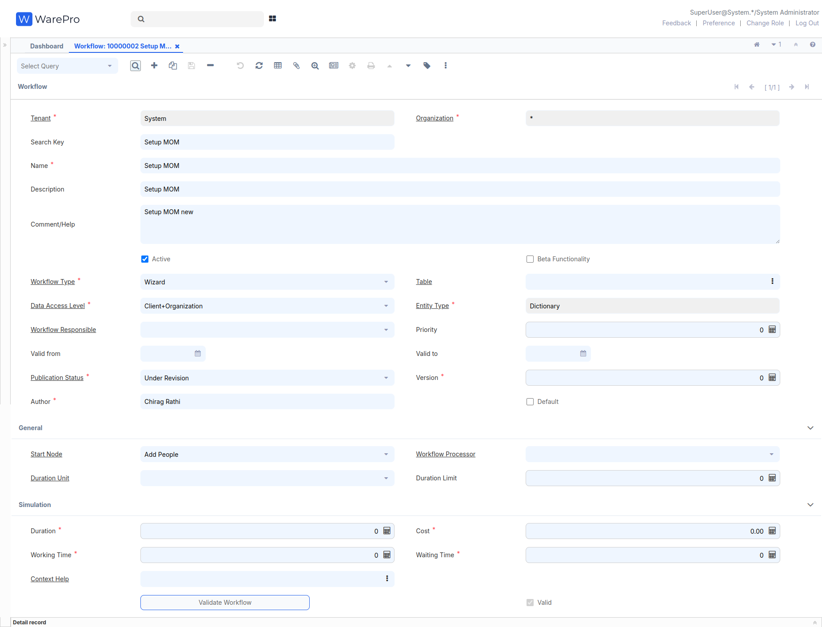

At the bottom left, go to the Node tab, enter it, and create four records:-

Name = Add People, Search Key = Add People, Entity Type - Dictionary, Action = User Window, Window = User
- Name = Status, Search Key = Status,
Entity Type - Dictionary, Action = Document Action,
Action = User Window, Window = MOM Status
- Name = MOM, Search Key = MOM,
Entity Type - Dictionary, Action = Document Action,
Action = User Window, Window = Minutes of Meeting
- Name = Report, Search Key = Report,
Entity Type - Dictionary, Action = Document Action,
Action = Apps Process, Process =MOM Report With View_MOMReportWithView

3. Use the search bar at the top left and enter Workflow Editor
Select the Workflow name(Select the same record while logged in as System for creating it) from the top-left toolbar
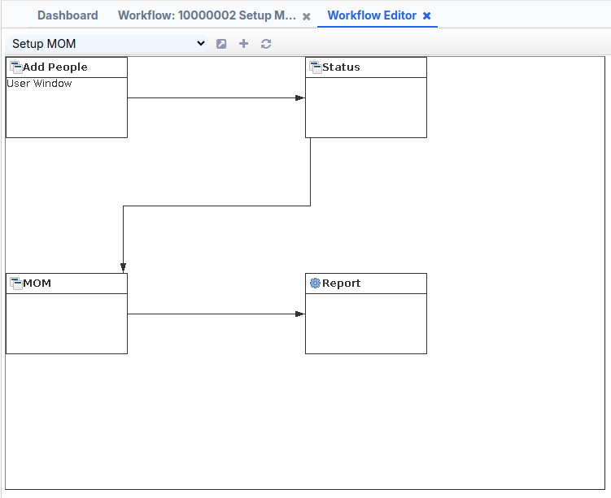

- Log out and log in as GardenAdmin/GardenAdmin with the GardenWorld Admin role.
- Use the search bar at the top left and enter Role to locate the Role window.
- In the Role window, use the search tool to find the role with the name GardenWorld Admin.
- Navigate to the Workflow Access tab at the middle-bottom section and click New Record.
- In the Workflow field, select Setup MOM.
- Check the Read Write checkbox and click Save.
- After saving, log out of the system and log in again.
- Open the menu tree and verify if the Setup MOM window is visible.

